**19CSE314 Software Engineering**

**Automated Elective Processing**

**CAUT**

**GROUP-3**

**Member Details**

|  |  |  |
| --- | --- | --- |
| **Roll No** | **Name** | **Role** |
| CB.EN.U4CSE19214 | E Santhosh Bharathi | Tester, Front End developer |
| CB.EN.U4CSE19225 | Maithreyan S | Backend Developer |
| CB.EN.U4CSE19243 | Saurav S | Backend Developer |
| CB.EN.U4CSE19259 | Tejaswi V | Business Analyst, Front End developer |
| CB.EN.U4CSE19263 | Viswabharathi K A | Project Manager |

**1)Preview of Project**

**About the project**

An application that allocates elective preference of students first come first serve basis automatically. The electives are predefined in the database and the number of electives and the respective credits change dynamically based on the academic year. The main functionality is to allocate electives for students based on their preference. If many students have opted for the same elective, students will be allocated based on the first come first serve basis. The remaining students will be allocated to the elective of their second or next preference based on the availability of seats. If there are over 150% applicants aspiring for the same course, the class would be split into two sections. This allocation will be based on seat availability and faculty availability.

**Stake holders**

* Students
* Teachers
* University Administration

**Modules**

1. **Student Login Module**- The student is required to login his/her college credentials to access the elective preference list and view the final elective allocation list
2. **Elective Selection module** - The student can block/reserve a seat in the favorable elective.
3. **Allocation of elective module** – Elective is allocated to the requested student if the seats are available else the electives are allocated based on student’s priority preference.
4. **Display** - The user can request to view the content.
5. **Elective Change module**- This module is used by the students who are willing to change his/her elective.

**Assumptions**

1.There is a pre-defined list of electives which have its own pre-requisites and faculties that are going to handle them.

2.Web Application (cross platform access)

3.Elective credit requirements must be met.

4.Students do not have the access to reorder the elective preference once they have submitted the preference form.

**Requirements**

**Students:**

1. Uses the student login portal to login and enter the preference page to select the electives for a particular semester.
2. The preferences page displays the available electives with the number of seats remaining and the relevant course information and pre-requisites.
3. Students can make reservations for electives if the present number of seats are full in the same course.
4. Students would be provided with their elective, batch (if any) and their respective batch instructor at the end of the selection phase.
5. Students can request to change their elective at the time given to them and/or finalize their choice.

**Faculties/Staffs:**

1. Login into faculty portal with faculty credentials.

2. The web page consists of the list of electives and the students who have preferred that elective.

3. Faculty can view the finalized list after the end of selection window.

**University administration:**

1. Offers a predefined set of electives for each semester that may change every academic year.
2. Lay out the prerequisites and eligibility criteria for every elective offered.
3. Allocates faculties to every elective course.
4. Take the decision to remove a particular elective course if there are not enough students to form a separate batch.
5. Take the decision to add an additional batch for the same elective if the reservation of that elective surpasses preset capacity.
6. Handles elective change for students who request to change their elective.
7. Add electives if needed

**Reports**

1. **Elective allocation report:** Final students list for every elective.
2. **Faculty allocation report:** A report on faculties allocated to every elective batch undertaking
3. **Elective change report**: List the details of students who requested to change electives.
4. **Elective Reallocation report:** Students who have been re-allocated because of course cancellation/ students' choice

**Software/Tools used:**

**Frontend:** Flutter

**Backend:** Node + Express

**Database:** MongoDB deployed with docker

**IDE:** Android Studio/ VS Code

**Agile Tracking:** JIRA

**Code Repository:** GitHub

**Schema**

**Tables before normalization:**

**Student Table**

|  |  |  |  |  |  |  |  |  |  |
| --- | --- | --- | --- | --- | --- | --- | --- | --- | --- |
| Student ID(PK) | Student name | Year | Semester | Course ID(FK) | Elective ID(FK) | Dept ID(FK) | Email | Username (FK) | Enrolment |

**Faculty Table**

|  |  |  |  |  |  |  |
| --- | --- | --- | --- | --- | --- | --- |
| Faculty ID(PK) | Faculty Name | Dept ID(FK) | Elective ID(FK) | Course ID(FK) | Qualifications | Date of Join |

**Department Table**

|  |  |  |
| --- | --- | --- |
| Dept ID(PK) | Dept Name | Dept HOD |

**Elective Table**

|  |  |  |  |  |  |  |
| --- | --- | --- | --- | --- | --- | --- |
| Elective ID(PK) | Elective Name | Prerequisite Course ID (FK) | Faculty ID(FK) | Dept ID(FK) | Semester | Credits |

**Core Course Table**

|  |  |  |  |  |
| --- | --- | --- | --- | --- |
| Course ID(PK) | Course Name | Semester | Dept ID(FK) | Credits |

**Login Table**

|  |  |  |
| --- | --- | --- |
| Username (PK) | Password | Microsoft login |

**Functional Dependencies:**

Student ID 🡪 Student Name

Student ID 🡪 Email

Student ID 🡪 Username

{Student ID, Semester} 🡪 year

Student ID 🡪 Class name

Faculty ID 🡪 Faculty name

Faculty ID 🡪 Date of join

Faculty ID 🡪 Qualification

Dept ID 🡪 Dept Name

Dept ID 🡪 Dept HOD

Course ID 🡪 Course Name

Course ID 🡪 Course_table.Credits

Elective ID 🡪 Elective Name

Elective ID 🡪 Elective_table.Credits

Username 🡪 Password

Student ID 🡪 Microsoft login

Student ID 🡪 Username

Course ID 🡪 Semester

Elective ID 🡪 Semester

{Student ID, Course ID} 🡪 Enrolment

{Student ID, Elective ID} 🡪 Enrolment

**Tables after normalization (Till 3NF):**

|  |  |  |  |  |  |  |
| --- | --- | --- | --- | --- | --- | --- |
| Student’s_ID | Student’s_Name | Year | Semester | Class_Name | Username | Email |

|  |  |  |  |  |
| --- | --- | --- | --- | --- |
| Faculty_ID | Faculty_Name | Faculty_DOJ | Faculty_qualification | Username |

|  |  |  |
| --- | --- | --- |
| Dept_ID | Dept_HOD | Dept_Name |

|  |  |  |  |
| --- | --- | --- | --- |
| Course_ID | Semester | Credits | Course_Name |

|  |  |  |
| --- | --- | --- |
| Elective_ID | Elective_details_PDF_link | Elective_Name |

|  |  |  |
| --- | --- | --- |
| Elective_ID | Dept_ID | Semester |

|  |  |  |
| --- | --- | --- |
| Student’s_ID | Elective_ID | Enrollment |

|  |  |  |
| --- | --- | --- |
| Student’s_ID | Course_ID | Enrollment |

|  |  |  |  |
| --- | --- | --- | --- |
| Faculty_ID | Semester | Course_ID | Elective_ID |

|  |  |  |
| --- | --- | --- |
| Username | Password | Microsoft_Login |

|  |  |  |
| --- | --- | --- |
| Student’s_ID | Faculty_ID | Dept_ID |

**Epics and User stories:**

**Invision chart:**

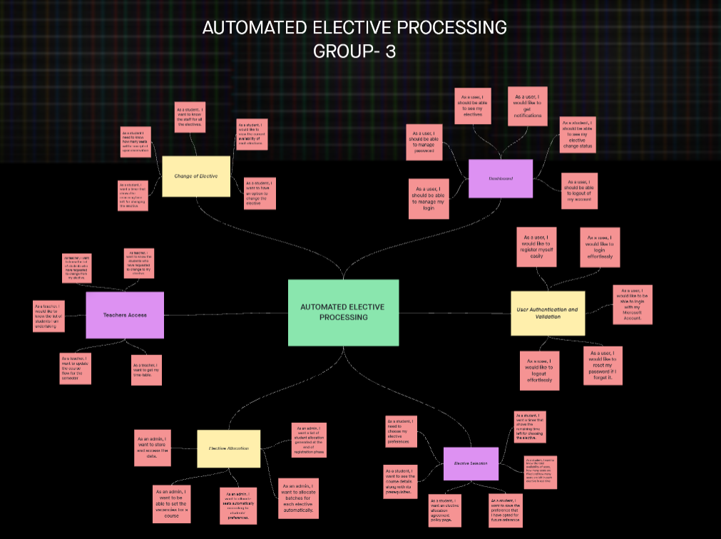

**2) Product Backlog**

**Epic: User Authentication and Validation**

* + - **As an admin, I would like to register users.**
    - **As a user, I would like to login effortlessly**
    - **As a user, I would like to reset my password if I forget it**
    - **As a user, I would like to be able to login effortlessly with my Microsoft Account**
    - **As a user, I would like to logout effortlessly**

**Epic: Dashboard**

* + - As a user, I should be able to manage password
    - As a user, I should be able to manage password
    - As a user, I would like to get notifications
    - As a student, I should be able to see my elective change status
    - As a user, I should be able to logout of my account

**Epic: Elective Selection**

* + - **As a student, I need to choose my elective preferences.**
    - **As a student, I want to see the course details along with its prerequisites**.
    - **As a student, I want an elective allocation agreement policy page.**
    - **As a student, I want to save the preference that I have opted for future reference**
    - **As a student, I want to know the total availability of seats, how many seats are filled and how many seats are left in each elective in real time.**
    - **As a student, I want a timer that shows the remaining time left for choosing the elective.**
* **Epic: Elective Allocation** 
  + - **As an admin, I want to store and access the data.**
    - **As an admin, I want to be able to set the vacancies for a course.**
    - **As an admin, I want to allocate seats automatically according to students’ preferences.**
    - **As an admin, I want to allocate batches for each elective.**
    - **As an admin, I want a list of student allocation generated at the end of registration phase.**
* **Epic: Change of Elective** 
  + - **Elective change request page: As a student, I want to have an option to change the elective.**
    - **Open and closed electives: As a student, I would like to view the current availability of each elective.**
    - **Reservation and Acceptance percentage: As a student I need to know how many seats will be accepted upon reservation**
    - **Time left: As a student, I want a timer that shows the remaining time left for changing the elective.**
    - **Elective details with staff Page details: As a student, I want to know the staff responsible for all the electives.**
* **Epic: Teacher's Access over the portal**
  + - **As teacher, I want to know the students who have requested to change to my elective.**
    - **As teacher, I want to know the list of students who have requested to change from my elective.**
    - **As a teacher, I would like to know the list of students I am undertaking**
    - **As a teacher, I want to update the course flow for the semester**
    - **As a teacher, I want to get my time-table.**

**3) UML Diagrams**

Use case diagram:



**Class Diagram**



**Time sequence diagram**



**Activity diagram**



**Statechart diagram**



**DFD level 1:**

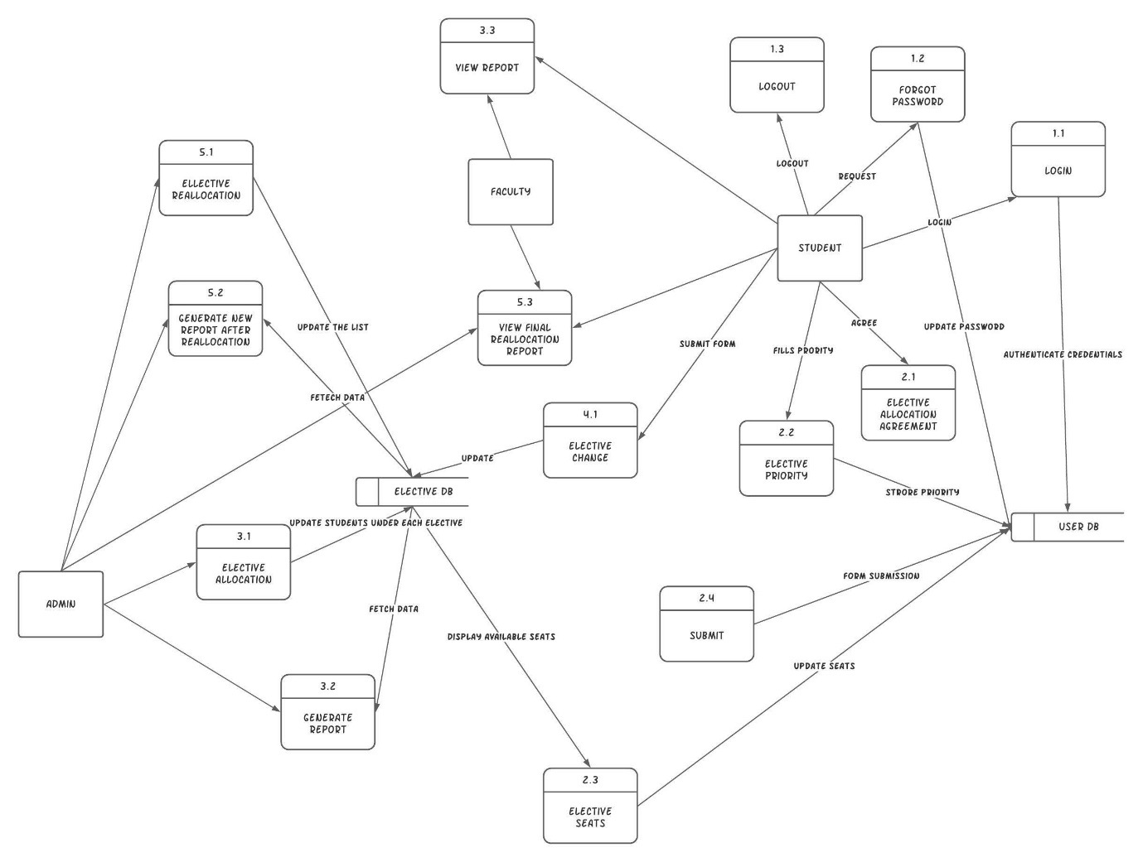

**DFD Level 2**

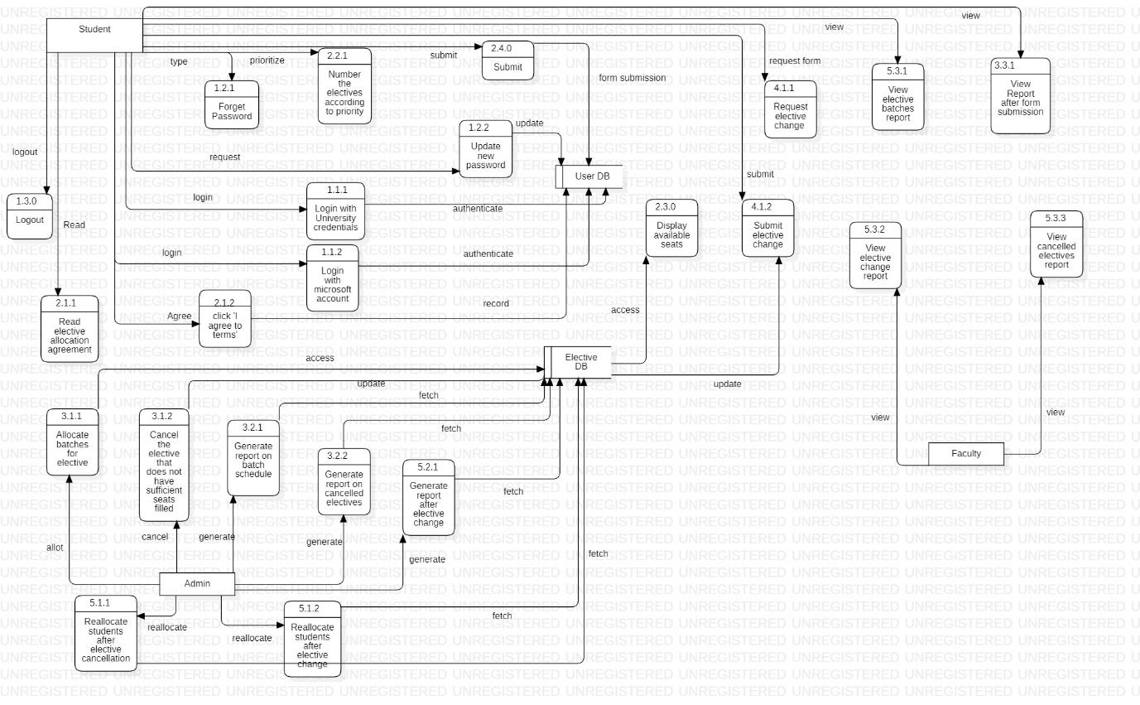

**4) Scrum Activities**

**Product Backlog:**

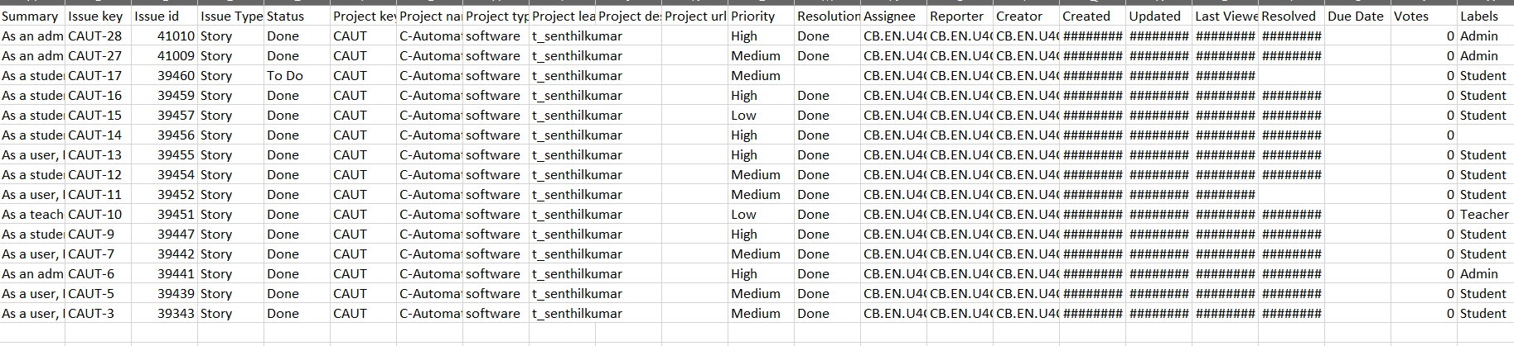

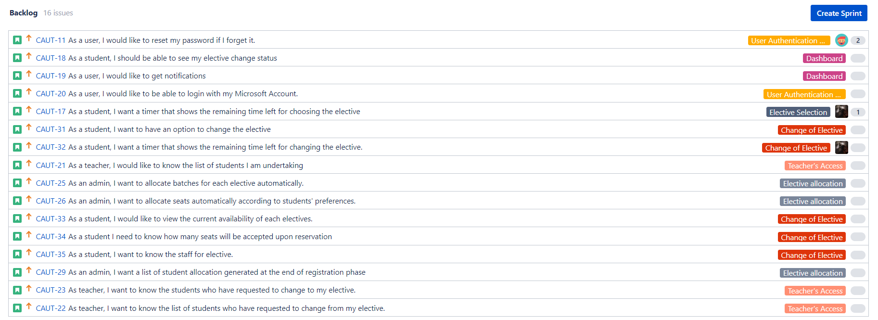

**4.1) Sprint 1 Backlog**



|  |  |
| --- | --- |
| [CAUT-28] [As an admin, I want to store and access elective information data](http://jira.amritanet.edu:8080/browse/CAUT-28) **Created: 10/Mar/22  Updated: 26/Mar/22  Resolved: 26/Mar/22** | |
| **Status:** | Done |
| **Project:** | [C-Automatingelectiveprocessing](http://jira.amritanet.edu:8080/secure/BrowseProject.jspa?id=10672) |
| **Component/s:** | None |
| **Affects Version/s:** | None |
| **Fix Version/s:** | None |

|  |  |  |  |
| --- | --- | --- | --- |
| **Type:** | Story | **Priority:** | High |
| **Reporter:** | [Viswabharathi KA](http://jira.amritanet.edu:8080/secure/ViewProfile.jspa?name=CB.EN.U4CSE19263) | **Assignee:** | [Saurav S](http://jira.amritanet.edu:8080/secure/ViewProfile.jspa?name=CB.EN.U4CSE19243) |
| **Resolution:** | Done | **Votes:** | 0 |
| **Labels:** | Admin | | |
| **Σ Remaining Estimate:** | Not Specified | **Remaining Estimate:** | Not Specified |
| **Σ Time Spent:** | Not Specified | **Time Spent:** | Not Specified |
| **Σ Original Estimate:** | Not Specified | **Original Estimate:** | Not Specified |

|  |  |  |  |  |  |  |  |  |  |  |  |  |  |  |  |  |  |  |  |  |  |  |  |  |  |  |  |  |  |  |  |  |  |  |  |  |
| --- | --- | --- | --- | --- | --- | --- | --- | --- | --- | --- | --- | --- | --- | --- | --- | --- | --- | --- | --- | --- | --- | --- | --- | --- | --- | --- | --- | --- | --- | --- | --- | --- | --- | --- | --- | --- |
| **Sub-Tasks:** | |  |  |  |  |  | | --- | --- | --- | --- | --- | | **Key** | **Summary** | **Type** | **Status** | **Assignee** | | [CAUT-49](http://jira.amritanet.edu:8080/browse/CAUT-49) | [Create required tables for the database](http://jira.amritanet.edu:8080/browse/CAUT-49) | Sub-task | Done | Maithreyan S | | [CAUT-50](http://jira.amritanet.edu:8080/browse/CAUT-50) | [Normalize the tables](http://jira.amritanet.edu:8080/browse/CAUT-50) | Sub-task | Done | Maithreyan S | | [CAUT-51](http://jira.amritanet.edu:8080/browse/CAUT-51) | [Design a Page for Admin's access over...](http://jira.amritanet.edu:8080/browse/CAUT-51) | Sub-task | Done | Viswabharathi KA | | [CAUT-65](http://jira.amritanet.edu:8080/browse/CAUT-65) | [Develop the page and connect it with ...](http://jira.amritanet.edu:8080/browse/CAUT-65) | Sub-task | Done | Maithreyan S | | [CAUT-88](http://jira.amritanet.edu:8080/browse/CAUT-88) | [Test the API calls get the required i...](http://jira.amritanet.edu:8080/browse/CAUT-88) | Sub-task | Done | Maithreyan S | | [CAUT-90](http://jira.amritanet.edu:8080/browse/CAUT-90) | [Add a field to enter number of seats ...](http://jira.amritanet.edu:8080/browse/CAUT-90) | Sub-task | Done | Maithreyan S | |
| **Epic Link:** | [Elective allocation](http://jira.amritanet.edu:8080/browse/CAUT-24) |
| **Sprint:** | CAUT Sprint 1 |

|  |  |
| --- | --- |
| [CAUT-27] [As an admin, I want to be able to set the vacancies for a course](http://jira.amritanet.edu:8080/browse/CAUT-27) **Created: 10/Mar/22  Updated: 29/Mar/22  Resolved: 29/Mar/22** | |
| **Status:** | Done |
| **Project:** | [C-Automatingelectiveprocessing](http://jira.amritanet.edu:8080/secure/BrowseProject.jspa?id=10672) |
| **Component/s:** | None |
| **Affects Version/s:** | None |
| **Fix Version/s:** | None |

|  |  |  |  |
| --- | --- | --- | --- |
| **Type:** | Story | **Priority:** | Medium |
| **Reporter:** | [Viswabharathi KA](http://jira.amritanet.edu:8080/secure/ViewProfile.jspa?name=CB.EN.U4CSE19263) | **Assignee:** | [Maithreyan S](http://jira.amritanet.edu:8080/secure/ViewProfile.jspa?name=CB.EN.U4CSE19225) |
| **Resolution:** | Done | **Votes:** | 0 |
| **Labels:** | Admin | | |
| **Σ Remaining Estimate:** | Not Specified | **Remaining Estimate:** | Not Specified |
| **Σ Time Spent:** | Not Specified | **Time Spent:** | Not Specified |
| **Σ Original Estimate:** | Not Specified | **Original Estimate:** | Not Specified |

|  |  |  |  |  |  |  |  |  |  |  |  |  |  |  |  |  |  |  |  |  |  |  |  |  |  |  |
| --- | --- | --- | --- | --- | --- | --- | --- | --- | --- | --- | --- | --- | --- | --- | --- | --- | --- | --- | --- | --- | --- | --- | --- | --- | --- | --- |
| **Sub-Tasks:** | |  |  |  |  |  | | --- | --- | --- | --- | --- | | **Key** | **Summary** | **Type** | **Status** | **Assignee** | | [CAUT-44](http://jira.amritanet.edu:8080/browse/CAUT-44) | [Create a form to set vacancies for th...](http://jira.amritanet.edu:8080/browse/CAUT-44) | Sub-task | Done | ESanthoshBharathi | | [CAUT-82](http://jira.amritanet.edu:8080/browse/CAUT-82) | [Add a batch size element for elective.](http://jira.amritanet.edu:8080/browse/CAUT-82) | Sub-task | Done | Maithreyan S | | [CAUT-83](http://jira.amritanet.edu:8080/browse/CAUT-83) | [Create a button in Admin dashboard an...](http://jira.amritanet.edu:8080/browse/CAUT-83) | Sub-task | Done | Tejaswi V | | [CAUT-84](http://jira.amritanet.edu:8080/browse/CAUT-84) | [Connect the elements of this page to ...](http://jira.amritanet.edu:8080/browse/CAUT-84) | Sub-task | Done | Saurav S | |
| **Epic Link:** | [Elective allocation](http://jira.amritanet.edu:8080/browse/CAUT-24) |
| **Sprint:** | CAUT Sprint 1 |

|  |  |
| --- | --- |
| [CAUT-17] [As a student, I want a timer that shows the remaining time left for choosing the elective](http://jira.amritanet.edu:8080/browse/CAUT-17) **Created: 23/Feb/22  Updated: 27/Mar/22** | |
| **Status:** | To Do |
| **Project:** | [C-Automatingelectiveprocessing](http://jira.amritanet.edu:8080/secure/BrowseProject.jspa?id=10672) |
| **Component/s:** | None |
| **Affects Version/s:** | None |
| **Fix Version/s:** | None |

|  |  |  |  |
| --- | --- | --- | --- |
| **Type:** | Story | **Priority:** | Medium |
| **Reporter:** | [Saurav S](http://jira.amritanet.edu:8080/secure/ViewProfile.jspa?name=CB.EN.U4CSE19243) | **Assignee:** | [Saurav S](http://jira.amritanet.edu:8080/secure/ViewProfile.jspa?name=CB.EN.U4CSE19243) |
| **Resolution:** | Unresolved | **Votes:** | 0 |
| **Labels:** | Student | | |
| **Remaining Estimate:** | Not Specified | | |
| **Time Spent:** | Not Specified | | |
| **Original Estimate:** | Not Specified | | |

|  |  |
| --- | --- |
| **Epic Link:** | [Elective Selection](http://jira.amritanet.edu:8080/browse/CAUT-4) |
| **Sprint:** | CAUT Sprint 1 |

|  |  |
| --- | --- |
| [CAUT-16] [As a student, I want to know the availability of seats for each elective](http://jira.amritanet.edu:8080/browse/CAUT-16) **Created: 23/Feb/22  Updated: 29/Mar/22  Resolved: 29/Mar/22** | |
| **Status:** | Done |
| **Project:** | [C-Automatingelectiveprocessing](http://jira.amritanet.edu:8080/secure/BrowseProject.jspa?id=10672) |
| **Component/s:** | None |
| **Affects Version/s:** | None |
| **Fix Version/s:** | None |

|  |  |  |  |
| --- | --- | --- | --- |
| **Type:** | Story | **Priority:** | High |
| **Reporter:** | [Tejaswi V](http://jira.amritanet.edu:8080/secure/ViewProfile.jspa?name=CB.EN.U4CSE19259) | **Assignee:** | [Tejaswi V](http://jira.amritanet.edu:8080/secure/ViewProfile.jspa?name=CB.EN.U4CSE19259) |
| **Resolution:** | Done | **Votes:** | 0 |
| **Labels:** | Student | | |
| **Σ Remaining Estimate:** | Not Specified | **Remaining Estimate:** | Not Specified |
| **Σ Time Spent:** | Not Specified | **Time Spent:** | Not Specified |
| **Σ Original Estimate:** | Not Specified | **Original Estimate:** | Not Specified |

|  |  |  |  |  |  |  |  |  |  |  |  |  |  |  |  |  |  |  |  |  |  |  |  |  |  |  |
| --- | --- | --- | --- | --- | --- | --- | --- | --- | --- | --- | --- | --- | --- | --- | --- | --- | --- | --- | --- | --- | --- | --- | --- | --- | --- | --- |
| **Sub-Tasks:** | |  |  |  |  |  | | --- | --- | --- | --- | --- | | **Key** | **Summary** | **Type** | **Status** | **Assignee** | | [CAUT-96](http://jira.amritanet.edu:8080/browse/CAUT-96) | [Add the seats section to the elective...](http://jira.amritanet.edu:8080/browse/CAUT-96) | Sub-task | Done | Saurav S | | [CAUT-97](http://jira.amritanet.edu:8080/browse/CAUT-97) | [make API request to get the number of...](http://jira.amritanet.edu:8080/browse/CAUT-97) | Sub-task | Done | Viswabharathi KA | | [CAUT-98](http://jira.amritanet.edu:8080/browse/CAUT-98) | [add the section to cards of each elec...](http://jira.amritanet.edu:8080/browse/CAUT-98) | Sub-task | Done | Saurav S | | [CAUT-99](http://jira.amritanet.edu:8080/browse/CAUT-99) | [Make updations dynamic](http://jira.amritanet.edu:8080/browse/CAUT-99) | Sub-task | Done | Tejaswi V | |
| **Epic Link:** | [Elective Selection](http://jira.amritanet.edu:8080/browse/CAUT-4) |
| **Sprint:** | CAUT Sprint 1 |

|  |  |
| --- | --- |
| [CAUT-15] [As a student, I want to save the preference that I have opted for future reference](http://jira.amritanet.edu:8080/browse/CAUT-15) **Created: 23/Feb/22  Updated: 29/Mar/22  Resolved: 29/Mar/22** | |
| **Status:** | Done |
| **Project:** | [C-Automatingelectiveprocessing](http://jira.amritanet.edu:8080/secure/BrowseProject.jspa?id=10672) |
| **Component/s:** | None |
| **Affects Version/s:** | None |
| **Fix Version/s:** | None |

|  |  |  |  |
| --- | --- | --- | --- |
| **Type:** | Story | **Priority:** | Low |
| **Reporter:** | [Maithreyan S](http://jira.amritanet.edu:8080/secure/ViewProfile.jspa?name=CB.EN.U4CSE19225) | **Assignee:** | [Maithreyan S](http://jira.amritanet.edu:8080/secure/ViewProfile.jspa?name=CB.EN.U4CSE19225) |
| **Resolution:** | Done | **Votes:** | 0 |
| **Labels:** | Student | | |
| **Σ Remaining Estimate:** | Not Specified | **Remaining Estimate:** | Not Specified |
| **Σ Time Spent:** | Not Specified | **Time Spent:** | Not Specified |
| **Σ Original Estimate:** | Not Specified | **Original Estimate:** | Not Specified |

|  |  |  |  |  |  |  |  |  |  |  |  |  |  |  |  |  |  |  |  |  |  |  |  |  |  |  |  |  |  |  |  |
| --- | --- | --- | --- | --- | --- | --- | --- | --- | --- | --- | --- | --- | --- | --- | --- | --- | --- | --- | --- | --- | --- | --- | --- | --- | --- | --- | --- | --- | --- | --- | --- |
| **Sub-Tasks:** | |  |  |  |  |  | | --- | --- | --- | --- | --- | | **Key** | **Summary** | **Type** | **Status** | **Assignee** | | [CAUT-100](http://jira.amritanet.edu:8080/browse/CAUT-100) | [design a section in dashboard for pre...](http://jira.amritanet.edu:8080/browse/CAUT-100) | Sub-task | Done | Saurav S | | [CAUT-101](http://jira.amritanet.edu:8080/browse/CAUT-101) | [Create cards and add elements to add ...](http://jira.amritanet.edu:8080/browse/CAUT-101) | Sub-task | Done | Tejaswi V | | [CAUT-102](http://jira.amritanet.edu:8080/browse/CAUT-102) | [Create API calls for the database](http://jira.amritanet.edu:8080/browse/CAUT-102) | Sub-task | Done | Maithreyan S | | [CAUT-103](http://jira.amritanet.edu:8080/browse/CAUT-103) | [Make API calls to the backend](http://jira.amritanet.edu:8080/browse/CAUT-103) | Sub-task | Done | Saurav S | | [CAUT-104](http://jira.amritanet.edu:8080/browse/CAUT-104) | [Display the registered Electives](http://jira.amritanet.edu:8080/browse/CAUT-104) | Sub-task | Done | ESanthoshBharathi | |
| **Epic Link:** | [Elective Selection](http://jira.amritanet.edu:8080/browse/CAUT-4) |
| **Sprint:** | CAUT Sprint 1 |

|  |  |
| --- | --- |
| [CAUT-14] [As a student, I want an elective allocation agreement policy page](http://jira.amritanet.edu:8080/browse/CAUT-14) **Created: 23/Feb/22  Updated: 26/Mar/22  Resolved: 26/Mar/22** | |
| **Status:** | Done |
| **Project:** | [C-Automatingelectiveprocessing](http://jira.amritanet.edu:8080/secure/BrowseProject.jspa?id=10672) |
| **Component/s:** | None |
| **Affects Version/s:** | None |
| **Fix Version/s:** | None |

|  |  |  |  |
| --- | --- | --- | --- |
| **Type:** | Story | **Priority:** | High |
| **Reporter:** | [ESanthoshBharathi](http://jira.amritanet.edu:8080/secure/ViewProfile.jspa?name=CB.EN.U4CSE19214) | **Assignee:** | [ESanthoshBharathi](http://jira.amritanet.edu:8080/secure/ViewProfile.jspa?name=CB.EN.U4CSE19214) |
| **Resolution:** | Done | **Votes:** | 0 |
| **Labels:** | None | | |
| **Σ Remaining Estimate:** | Not Specified | **Remaining Estimate:** | Not Specified |
| **Σ Time Spent:** | Not Specified | **Time Spent:** | Not Specified |
| **Σ Original Estimate:** | Not Specified | **Original Estimate:** | Not Specified |

|  |  |  |  |  |  |  |  |  |  |  |  |  |  |  |  |  |  |  |  |  |  |  |  |  |  |  |  |  |  |  |  |
| --- | --- | --- | --- | --- | --- | --- | --- | --- | --- | --- | --- | --- | --- | --- | --- | --- | --- | --- | --- | --- | --- | --- | --- | --- | --- | --- | --- | --- | --- | --- | --- |
| **Sub-Tasks:** | |  |  |  |  |  | | --- | --- | --- | --- | --- | | **Key** | **Summary** | **Type** | **Status** | **Assignee** | | [CAUT-45](http://jira.amritanet.edu:8080/browse/CAUT-45) | [Design an elective agreement policy page](http://jira.amritanet.edu:8080/browse/CAUT-45) | Sub-task | Done | Tejaswi V | | [CAUT-46](http://jira.amritanet.edu:8080/browse/CAUT-46) | [Add a button to accept the agreements](http://jira.amritanet.edu:8080/browse/CAUT-46) | Sub-task | Done | Tejaswi V | | [CAUT-68](http://jira.amritanet.edu:8080/browse/CAUT-68) | [List out all the policies and terms f...](http://jira.amritanet.edu:8080/browse/CAUT-68) | Sub-task | Done | Tejaswi V | | [CAUT-77](http://jira.amritanet.edu:8080/browse/CAUT-77) | [Create a button on the student dashbo...](http://jira.amritanet.edu:8080/browse/CAUT-77) | Sub-task | Done | Saurav S | | [CAUT-78](http://jira.amritanet.edu:8080/browse/CAUT-78) | [Navigate the Accept agreement button ...](http://jira.amritanet.edu:8080/browse/CAUT-78) | Sub-task | Done | ESanthoshBharathi | |
| **Epic Link:** | [Elective Selection](http://jira.amritanet.edu:8080/browse/CAUT-4) |
| **Sprint:** | CAUT Sprint 1 |

|  |  |
| --- | --- |
| [CAUT-13] [As a user, I should be able to see my electives](http://jira.amritanet.edu:8080/browse/CAUT-13) **Created: 23/Feb/22  Updated: 26/Mar/22  Resolved: 26/Mar/22** | |
| **Status:** | Done |
| **Project:** | [C-Automatingelectiveprocessing](http://jira.amritanet.edu:8080/secure/BrowseProject.jspa?id=10672) |
| **Component/s:** | None |
| **Affects Version/s:** | None |
| **Fix Version/s:** | None |

|  |  |  |  |
| --- | --- | --- | --- |
| **Type:** | Story | **Priority:** | High |
| **Reporter:** | [Viswabharathi KA](http://jira.amritanet.edu:8080/secure/ViewProfile.jspa?name=CB.EN.U4CSE19263) | **Assignee:** | [Viswabharathi KA](http://jira.amritanet.edu:8080/secure/ViewProfile.jspa?name=CB.EN.U4CSE19263) |
| **Resolution:** | Done | **Votes:** | 0 |
| **Labels:** | Student | | |
| **Σ Remaining Estimate:** | Not Specified | **Remaining Estimate:** | Not Specified |
| **Σ Time Spent:** | Not Specified | **Time Spent:** | Not Specified |
| **Σ Original Estimate:** | Not Specified | **Original Estimate:** | Not Specified |

|  |  |  |  |  |  |  |  |  |  |  |  |  |  |  |  |  |  |  |  |  |  |  |  |  |  |  |  |  |  |  |  |
| --- | --- | --- | --- | --- | --- | --- | --- | --- | --- | --- | --- | --- | --- | --- | --- | --- | --- | --- | --- | --- | --- | --- | --- | --- | --- | --- | --- | --- | --- | --- | --- |
| **Sub-Tasks:** | |  |  |  |  |  | | --- | --- | --- | --- | --- | | **Key** | **Summary** | **Type** | **Status** | **Assignee** | | [CAUT-40](http://jira.amritanet.edu:8080/browse/CAUT-40) | [Design the Dashboard Page](http://jira.amritanet.edu:8080/browse/CAUT-40) | Sub-task | Done | Viswabharathi KA | | [CAUT-41](http://jira.amritanet.edu:8080/browse/CAUT-41) | [Add widgets to the Dashboard](http://jira.amritanet.edu:8080/browse/CAUT-41) | Sub-task | Done | Viswabharathi KA | | [CAUT-64](http://jira.amritanet.edu:8080/browse/CAUT-64) | [Add icons to to the functions](http://jira.amritanet.edu:8080/browse/CAUT-64) | Sub-task | Done | Viswabharathi KA | | [CAUT-85](http://jira.amritanet.edu:8080/browse/CAUT-85) | [Add Calendar to dashboard](http://jira.amritanet.edu:8080/browse/CAUT-85) | Sub-task | Done | Viswabharathi KA | | [CAUT-86](http://jira.amritanet.edu:8080/browse/CAUT-86) | [Design a widget in the dashboard scre...](http://jira.amritanet.edu:8080/browse/CAUT-86) | Sub-task | Done | Saurav S | |
| **Epic Link:** | [Dashboard](http://jira.amritanet.edu:8080/browse/CAUT-2) |
| **Sprint:** | CAUT Sprint 1 |

|  |  |
| --- | --- |
| [CAUT-12] [As a student, I want to see the course details along with the prerequisites](http://jira.amritanet.edu:8080/browse/CAUT-12) **Created: 23/Feb/22  Updated: 29/Mar/22  Resolved: 29/Mar/22** | |
| **Status:** | Done |
| **Project:** | [C-Automatingelectiveprocessing](http://jira.amritanet.edu:8080/secure/BrowseProject.jspa?id=10672) |
| **Component/s:** | None |
| **Affects Version/s:** | None |
| **Fix Version/s:** | None |

|  |  |  |  |
| --- | --- | --- | --- |
| **Type:** | Story | **Priority:** | Medium |
| **Reporter:** | [Tejaswi V](http://jira.amritanet.edu:8080/secure/ViewProfile.jspa?name=CB.EN.U4CSE19259) | **Assignee:** | [Tejaswi V](http://jira.amritanet.edu:8080/secure/ViewProfile.jspa?name=CB.EN.U4CSE19259) |
| **Resolution:** | Done | **Votes:** | 0 |
| **Labels:** | Student | | |
| **Σ Remaining Estimate:** | Not Specified | **Remaining Estimate:** | Not Specified |
| **Σ Time Spent:** | Not Specified | **Time Spent:** | Not Specified |
| **Σ Original Estimate:** | Not Specified | **Original Estimate:** | Not Specified |

|  |  |  |  |  |  |  |  |  |  |  |  |  |  |  |  |  |  |  |  |  |  |
| --- | --- | --- | --- | --- | --- | --- | --- | --- | --- | --- | --- | --- | --- | --- | --- | --- | --- | --- | --- | --- | --- |
| **Sub-Tasks:** | |  |  |  |  |  | | --- | --- | --- | --- | --- | | **Key** | **Summary** | **Type** | **Status** | **Assignee** | | [CAUT-105](http://jira.amritanet.edu:8080/browse/CAUT-105) | [Create a hyperlink for every listed e...](http://jira.amritanet.edu:8080/browse/CAUT-105) | Sub-task | Done | Maithreyan S | | [CAUT-106](http://jira.amritanet.edu:8080/browse/CAUT-106) | [Design a separate webpage that shows ...](http://jira.amritanet.edu:8080/browse/CAUT-106) | Sub-task | Done | Tejaswi V | | [CAUT-108](http://jira.amritanet.edu:8080/browse/CAUT-108) | [navigate to the next page](http://jira.amritanet.edu:8080/browse/CAUT-108) | Sub-task | Done | Tejaswi V | |
| **Epic Link:** | [Elective Selection](http://jira.amritanet.edu:8080/browse/CAUT-4) |
| **Sprint:** | CAUT Sprint 1 |

|  |  |
| --- | --- |
| [CAUT-11] [As a user, I would like to reset my password if I forget it.](http://jira.amritanet.edu:8080/browse/CAUT-11) **Created: 23/Feb/22  Updated: 26/Mar/22** | |
| **Status:** | To Do |
| **Project:** | [C-Automatingelectiveprocessing](http://jira.amritanet.edu:8080/secure/BrowseProject.jspa?id=10672) |
| **Component/s:** | None |
| **Affects Version/s:** | None |
| **Fix Version/s:** | None |

|  |  |  |  |
| --- | --- | --- | --- |
| **Type:** | Story | **Priority:** | Medium |
| **Reporter:** | [ESanthoshBharathi](http://jira.amritanet.edu:8080/secure/ViewProfile.jspa?name=CB.EN.U4CSE19214) | **Assignee:** | [ESanthoshBharathi](http://jira.amritanet.edu:8080/secure/ViewProfile.jspa?name=CB.EN.U4CSE19214) |
| **Resolution:** | Unresolved | **Votes:** | 0 |
| **Labels:** | Student, Teacher | | |
| **Remaining Estimate:** | Not Specified | | |
| **Time Spent:** | Not Specified | | |
| **Original Estimate:** | Not Specified | | |

|  |  |
| --- | --- |
| **Epic Link:** | [User Authentication and Validation](http://jira.amritanet.edu:8080/browse/CAUT-1) |

|  |  |
| --- | --- |
| **Description** |  |

|  |
| --- |
| forgot password button that redirects the user to screen to change the forgotten password |

|  |  |
| --- | --- |
| [CAUT-10] [As a teacher, I want to update the course flow for the semester](http://jira.amritanet.edu:8080/browse/CAUT-10) **Created: 23/Feb/22  Updated: 29/Mar/22  Resolved: 29/Mar/22** | |
| **Status:** | Done |
| **Project:** | [C-Automatingelectiveprocessing](http://jira.amritanet.edu:8080/secure/BrowseProject.jspa?id=10672) |
| **Component/s:** | None |
| **Affects Version/s:** | None |
| **Fix Version/s:** | None |

|  |  |  |  |
| --- | --- | --- | --- |
| **Type:** | Story | **Priority:** | Low |
| **Reporter:** | [Viswabharathi KA](http://jira.amritanet.edu:8080/secure/ViewProfile.jspa?name=CB.EN.U4CSE19263) | **Assignee:** | [Viswabharathi KA](http://jira.amritanet.edu:8080/secure/ViewProfile.jspa?name=CB.EN.U4CSE19263) |
| **Resolution:** | Done | **Votes:** | 0 |
| **Labels:** | Teacher | | |
| **Σ Remaining Estimate:** | Not Specified | **Remaining Estimate:** | Not Specified |
| **Σ Time Spent:** | Not Specified | **Time Spent:** | Not Specified |
| **Σ Original Estimate:** | Not Specified | **Original Estimate:** | Not Specified |

|  |  |  |  |  |  |  |  |  |  |  |  |  |  |  |  |  |  |  |  |  |  |  |  |  |  |  |  |  |  |  |  |  |  |  |  |  |
| --- | --- | --- | --- | --- | --- | --- | --- | --- | --- | --- | --- | --- | --- | --- | --- | --- | --- | --- | --- | --- | --- | --- | --- | --- | --- | --- | --- | --- | --- | --- | --- | --- | --- | --- | --- | --- |
| **Sub-Tasks:** | |  |  |  |  |  | | --- | --- | --- | --- | --- | | **Key** | **Summary** | **Type** | **Status** | **Assignee** | | [CAUT-47](http://jira.amritanet.edu:8080/browse/CAUT-47) | [Design Faculty Dashboard](http://jira.amritanet.edu:8080/browse/CAUT-47) | Sub-task | Done | ESanthoshBharathi | | [CAUT-48](http://jira.amritanet.edu:8080/browse/CAUT-48) | [Develop the Faculty Dashboard](http://jira.amritanet.edu:8080/browse/CAUT-48) | Sub-task | Done | ESanthoshBharathi | | [CAUT-55](http://jira.amritanet.edu:8080/browse/CAUT-55) | [Design a page for Course Flow](http://jira.amritanet.edu:8080/browse/CAUT-55) | Sub-task | Done | Tejaswi V | | [CAUT-58](http://jira.amritanet.edu:8080/browse/CAUT-58) | [Add the required widgets for the cour...](http://jira.amritanet.edu:8080/browse/CAUT-58) | Sub-task | Done | ESanthoshBharathi | | [CAUT-63](http://jira.amritanet.edu:8080/browse/CAUT-63) | [Develop a Dynamic Courseflow Page](http://jira.amritanet.edu:8080/browse/CAUT-63) | Sub-task | Done | Tejaswi V | | [CAUT-89](http://jira.amritanet.edu:8080/browse/CAUT-89) | [Add a button to navigate it to the ne...](http://jira.amritanet.edu:8080/browse/CAUT-89) | Sub-task | Done | Tejaswi V | |
| **Epic Link:** | [Teacher's Access](http://jira.amritanet.edu:8080/browse/CAUT-8) |
| **Sprint:** | CAUT Sprint 1 |

|  |  |
| --- | --- |
| [CAUT-9] [As a student, I need to give my elective preferences](http://jira.amritanet.edu:8080/browse/CAUT-9) **Created: 23/Feb/22  Updated: 26/Mar/22  Resolved: 26/Mar/22** | |
| **Status:** | Done |
| **Project:** | [C-Automatingelectiveprocessing](http://jira.amritanet.edu:8080/secure/BrowseProject.jspa?id=10672) |
| **Component/s:** | None |
| **Affects Version/s:** | None |
| **Fix Version/s:** | None |

|  |  |  |  |
| --- | --- | --- | --- |
| **Type:** | Story | **Priority:** | High |
| **Reporter:** | [Tejaswi V](http://jira.amritanet.edu:8080/secure/ViewProfile.jspa?name=CB.EN.U4CSE19259) | **Assignee:** | [Tejaswi V](http://jira.amritanet.edu:8080/secure/ViewProfile.jspa?name=CB.EN.U4CSE19259) |
| **Resolution:** | Done | **Votes:** | 0 |
| **Labels:** | Student | | |
| **Σ Remaining Estimate:** | Not Specified | **Remaining Estimate:** | Not Specified |
| **Σ Time Spent:** | Not Specified | **Time Spent:** | Not Specified |
| **Σ Original Estimate:** | Not Specified | **Original Estimate:** | Not Specified |

|  |  |  |  |  |  |  |  |  |  |  |  |  |  |  |  |  |  |  |  |  |  |  |  |  |  |  |  |  |  |  |  |
| --- | --- | --- | --- | --- | --- | --- | --- | --- | --- | --- | --- | --- | --- | --- | --- | --- | --- | --- | --- | --- | --- | --- | --- | --- | --- | --- | --- | --- | --- | --- | --- |
| **Sub-Tasks:** | |  |  |  |  |  | | --- | --- | --- | --- | --- | | **Key** | **Summary** | **Type** | **Status** | **Assignee** | | [CAUT-53](http://jira.amritanet.edu:8080/browse/CAUT-53) | [design a form to get the preferences ...](http://jira.amritanet.edu:8080/browse/CAUT-53) | Sub-task | Done | Tejaswi V | | [CAUT-54](http://jira.amritanet.edu:8080/browse/CAUT-54) | [develop and add the required widgets](http://jira.amritanet.edu:8080/browse/CAUT-54) | Sub-task | Done | Saurav S | | [CAUT-79](http://jira.amritanet.edu:8080/browse/CAUT-79) | [Add a number field alongside the elec...](http://jira.amritanet.edu:8080/browse/CAUT-79) | Sub-task | Done | ESanthoshBharathi | | [CAUT-80](http://jira.amritanet.edu:8080/browse/CAUT-80) | [Create a popup window that asks for c...](http://jira.amritanet.edu:8080/browse/CAUT-80) | Sub-task | Done | Saurav S | | [CAUT-81](http://jira.amritanet.edu:8080/browse/CAUT-81) | [Add a query to display an error messa...](http://jira.amritanet.edu:8080/browse/CAUT-81) | Sub-task | Done | Maithreyan S | |
| **Epic Link:** | [Elective Selection](http://jira.amritanet.edu:8080/browse/CAUT-4) |
| **Sprint:** | CAUT Sprint 1 |

|  |  |
| --- | --- |
| [CAUT-7] [As a user, I would like to login effortlessly](http://jira.amritanet.edu:8080/browse/CAUT-7) **Created: 23/Feb/22  Updated: 25/Mar/22  Resolved: 25/Mar/22** | |
| **Status:** | Done |
| **Project:** | [C-Automatingelectiveprocessing](http://jira.amritanet.edu:8080/secure/BrowseProject.jspa?id=10672) |
| **Component/s:** | None |
| **Affects Version/s:** | None |
| **Fix Version/s:** | None |

|  |  |  |  |
| --- | --- | --- | --- |
| **Type:** | Story | **Priority:** | Medium |
| **Reporter:** | [ESanthoshBharathi](http://jira.amritanet.edu:8080/secure/ViewProfile.jspa?name=CB.EN.U4CSE19214) | **Assignee:** | [ESanthoshBharathi](http://jira.amritanet.edu:8080/secure/ViewProfile.jspa?name=CB.EN.U4CSE19214) |
| **Resolution:** | Done | **Votes:** | 0 |
| **Labels:** | Student, Teacher | | |
| **Σ Remaining Estimate:** | Not Specified | **Remaining Estimate:** | Not Specified |
| **Σ Time Spent:** | Not Specified | **Time Spent:** | Not Specified |
| **Σ Original Estimate:** | Not Specified | **Original Estimate:** | Not Specified |

|  |  |  |  |  |  |  |  |  |  |  |  |  |  |  |  |  |  |  |  |  |  |  |  |  |  |  |  |  |  |  |  |  |  |  |  |  |
| --- | --- | --- | --- | --- | --- | --- | --- | --- | --- | --- | --- | --- | --- | --- | --- | --- | --- | --- | --- | --- | --- | --- | --- | --- | --- | --- | --- | --- | --- | --- | --- | --- | --- | --- | --- | --- |
| **Sub-Tasks:** | |  |  |  |  |  | | --- | --- | --- | --- | --- | | **Key** | **Summary** | **Type** | **Status** | **Assignee** | | [CAUT-36](http://jira.amritanet.edu:8080/browse/CAUT-36) | [Design a Login Page](http://jira.amritanet.edu:8080/browse/CAUT-36) | Sub-task | Done | ESanthoshBharathi | | [CAUT-37](http://jira.amritanet.edu:8080/browse/CAUT-37) | [Validate the desired user](http://jira.amritanet.edu:8080/browse/CAUT-37) | Sub-task | Done | Maithreyan S | | [CAUT-38](http://jira.amritanet.edu:8080/browse/CAUT-38) | [Create Login API calls](http://jira.amritanet.edu:8080/browse/CAUT-38) | Sub-task | Done | Saurav S | | [CAUT-39](http://jira.amritanet.edu:8080/browse/CAUT-39) | [Use API calls in front-end](http://jira.amritanet.edu:8080/browse/CAUT-39) | Sub-task | Done | ESanthoshBharathi | | [CAUT-61](http://jira.amritanet.edu:8080/browse/CAUT-61) | [Navigate the login Button to the next...](http://jira.amritanet.edu:8080/browse/CAUT-61) | Sub-task | Done | ESanthoshBharathi | | [CAUT-62](http://jira.amritanet.edu:8080/browse/CAUT-62) | [Add the required widgets to the Login...](http://jira.amritanet.edu:8080/browse/CAUT-62) | Sub-task | Done | Tejaswi V | |
| **Epic Link:** | [User Authentication and Validation](http://jira.amritanet.edu:8080/browse/CAUT-1) |
| **Sprint:** | CAUT Sprint 1 |

|  |  |
| --- | --- |
| **Description** |  |

|  |
| --- |
| to create login page for all the users. |

|  |  |
| --- | --- |
| [CAUT-6] [As an admin, I would like to register students](http://jira.amritanet.edu:8080/browse/CAUT-6) **Created: 23/Feb/22  Updated: 26/Mar/22  Resolved: 26/Mar/22** | |
| **Status:** | Done |
| **Project:** | [C-Automatingelectiveprocessing](http://jira.amritanet.edu:8080/secure/BrowseProject.jspa?id=10672) |
| **Component/s:** | None |
| **Affects Version/s:** | None |
| **Fix Version/s:** | None |

|  |  |  |  |
| --- | --- | --- | --- |
| **Type:** | Story | **Priority:** | High |
| **Reporter:** | [Maithreyan S](http://jira.amritanet.edu:8080/secure/ViewProfile.jspa?name=CB.EN.U4CSE19225) | **Assignee:** | [Maithreyan S](http://jira.amritanet.edu:8080/secure/ViewProfile.jspa?name=CB.EN.U4CSE19225) |
| **Resolution:** | Done | **Votes:** | 0 |
| **Labels:** | Admin, Student, Teacher | | |
| **Σ Remaining Estimate:** | Not Specified | **Remaining Estimate:** | Not Specified |
| **Σ Time Spent:** | Not Specified | **Time Spent:** | Not Specified |
| **Σ Original Estimate:** | Not Specified | **Original Estimate:** | Not Specified |

|  |  |  |  |  |  |  |  |  |  |  |  |  |  |  |  |  |  |  |  |  |  |  |  |  |  |  |  |  |  |  |  |  |  |  |  |  |  |  |  |  |  |
| --- | --- | --- | --- | --- | --- | --- | --- | --- | --- | --- | --- | --- | --- | --- | --- | --- | --- | --- | --- | --- | --- | --- | --- | --- | --- | --- | --- | --- | --- | --- | --- | --- | --- | --- | --- | --- | --- | --- | --- | --- | --- |
| **Sub-Tasks:** | |  |  |  |  |  | | --- | --- | --- | --- | --- | | **Key** | **Summary** | **Type** | **Status** | **Assignee** | | [CAUT-42](http://jira.amritanet.edu:8080/browse/CAUT-42) | [Create a form to add profiles](http://jira.amritanet.edu:8080/browse/CAUT-42) | Sub-task | Done | Saurav S | | [CAUT-43](http://jira.amritanet.edu:8080/browse/CAUT-43) | [add the profiles to database](http://jira.amritanet.edu:8080/browse/CAUT-43) | Sub-task | Done | Maithreyan S | | [CAUT-52](http://jira.amritanet.edu:8080/browse/CAUT-52) | [Create the required tables for studen...](http://jira.amritanet.edu:8080/browse/CAUT-52) | Sub-task | Done | Maithreyan S | | [CAUT-56](http://jira.amritanet.edu:8080/browse/CAUT-56) | [Validate the profiles in front-end](http://jira.amritanet.edu:8080/browse/CAUT-56) | Sub-task | Done | Saurav S | | [CAUT-57](http://jira.amritanet.edu:8080/browse/CAUT-57) | [Create API calls for registering the ...](http://jira.amritanet.edu:8080/browse/CAUT-57) | Sub-task | Done | Saurav S | | [CAUT-59](http://jira.amritanet.edu:8080/browse/CAUT-59) | [Add a global function to invoke notif...](http://jira.amritanet.edu:8080/browse/CAUT-59) | Sub-task | Done | Viswabharathi KA | | [CAUT-60](http://jira.amritanet.edu:8080/browse/CAUT-60) | [Validate the Profiles in Backend](http://jira.amritanet.edu:8080/browse/CAUT-60) | Sub-task | Done | Maithreyan S | |
| **Epic Link:** | [User Authentication and Validation](http://jira.amritanet.edu:8080/browse/CAUT-1) |
| **Sprint:** | CAUT Sprint 1 |

|  |  |
| --- | --- |
| [CAUT-5] [As a user, I should be able to logout of my account](http://jira.amritanet.edu:8080/browse/CAUT-5) **Created: 23/Feb/22  Updated: 26/Mar/22  Resolved: 26/Mar/22** | |
| **Status:** | Done |
| **Project:** | [C-Automatingelectiveprocessing](http://jira.amritanet.edu:8080/secure/BrowseProject.jspa?id=10672) |
| **Component/s:** | None |
| **Affects Version/s:** | None |
| **Fix Version/s:** | None |

|  |  |  |  |
| --- | --- | --- | --- |
| **Type:** | Story | **Priority:** | Medium |
| **Reporter:** | [Saurav S](http://jira.amritanet.edu:8080/secure/ViewProfile.jspa?name=CB.EN.U4CSE19243) | **Assignee:** | [Saurav S](http://jira.amritanet.edu:8080/secure/ViewProfile.jspa?name=CB.EN.U4CSE19243) |
| **Resolution:** | Done | **Votes:** | 0 |
| **Labels:** | Student, Teacher | | |
| **Σ Remaining Estimate:** | Not Specified | **Remaining Estimate:** | Not Specified |
| **Σ Time Spent:** | Not Specified | **Time Spent:** | Not Specified |
| **Σ Original Estimate:** | Not Specified | **Original Estimate:** | Not Specified |

|  |  |  |  |  |  |  |  |  |  |  |  |  |  |  |  |  |  |  |  |  |  |  |  |  |  |  |  |  |  |  |  |
| --- | --- | --- | --- | --- | --- | --- | --- | --- | --- | --- | --- | --- | --- | --- | --- | --- | --- | --- | --- | --- | --- | --- | --- | --- | --- | --- | --- | --- | --- | --- | --- |
| **Sub-Tasks:** | |  |  |  |  |  | | --- | --- | --- | --- | --- | | **Key** | **Summary** | **Type** | **Status** | **Assignee** | | [CAUT-72](http://jira.amritanet.edu:8080/browse/CAUT-72) | [Design a button for the user to Logout](http://jira.amritanet.edu:8080/browse/CAUT-72) | Sub-task | Done | Saurav S | | [CAUT-73](http://jira.amritanet.edu:8080/browse/CAUT-73) | [Navigate the Logout button to Logout ...](http://jira.amritanet.edu:8080/browse/CAUT-73) | Sub-task | Done | Saurav S | | [CAUT-74](http://jira.amritanet.edu:8080/browse/CAUT-74) | [Create a Link that Navigates the User...](http://jira.amritanet.edu:8080/browse/CAUT-74) | Sub-task | Done | ESanthoshBharathi | | [CAUT-75](http://jira.amritanet.edu:8080/browse/CAUT-75) | [Add the required widgets to the page ...](http://jira.amritanet.edu:8080/browse/CAUT-75) | Sub-task | Done | Tejaswi V | | [CAUT-87](http://jira.amritanet.edu:8080/browse/CAUT-87) | [Design Logout Screen](http://jira.amritanet.edu:8080/browse/CAUT-87) | Sub-task | Done | Viswabharathi KA | |
| **Epic Link:** | [Dashboard](http://jira.amritanet.edu:8080/browse/CAUT-2) |
| **Sprint:** | CAUT Sprint 1 |

|  |  |
| --- | --- |
| [CAUT-3] [As a user, I should be able to manage my password](http://jira.amritanet.edu:8080/browse/CAUT-3) **Created: 23/Feb/22  Updated: 29/Mar/22  Resolved: 29/Mar/22** | |
| **Status:** | Done |
| **Project:** | [C-Automatingelectiveprocessing](http://jira.amritanet.edu:8080/secure/BrowseProject.jspa?id=10672) |
| **Component/s:** | None |
| **Affects Version/s:** | None |
| **Fix Version/s:** | None |

|  |  |  |  |
| --- | --- | --- | --- |
| **Type:** | Story | **Priority:** | Medium |
| **Reporter:** | [Viswabharathi KA](http://jira.amritanet.edu:8080/secure/ViewProfile.jspa?name=CB.EN.U4CSE19263) | **Assignee:** | [Viswabharathi KA](http://jira.amritanet.edu:8080/secure/ViewProfile.jspa?name=CB.EN.U4CSE19263) |
| **Resolution:** | Done | **Votes:** | 0 |
| **Labels:** | Student, Teacher | | |
| **Σ Remaining Estimate:** | Not Specified | **Remaining Estimate:** | Not Specified |
| **Σ Time Spent:** | Not Specified | **Time Spent:** | Not Specified |
| **Σ Original Estimate:** | Not Specified | **Original Estimate:** | Not Specified |

|  |  |  |  |  |  |  |  |  |  |  |  |  |  |  |  |  |  |  |  |  |  |  |  |  |  |  |  |  |  |  |  |
| --- | --- | --- | --- | --- | --- | --- | --- | --- | --- | --- | --- | --- | --- | --- | --- | --- | --- | --- | --- | --- | --- | --- | --- | --- | --- | --- | --- | --- | --- | --- | --- |
| **Sub-Tasks:** | |  |  |  |  |  | | --- | --- | --- | --- | --- | | **Key** | **Summary** | **Type** | **Status** | **Assignee** | | [CAUT-91](http://jira.amritanet.edu:8080/browse/CAUT-91) | [design a manage password page](http://jira.amritanet.edu:8080/browse/CAUT-91) | Sub-task | Done | Viswabharathi KA | | [CAUT-92](http://jira.amritanet.edu:8080/browse/CAUT-92) | [develop a manage password page](http://jira.amritanet.edu:8080/browse/CAUT-92) | Sub-task | Done | ESanthoshBharathi | | [CAUT-93](http://jira.amritanet.edu:8080/browse/CAUT-93) | [add required widgets for the page](http://jira.amritanet.edu:8080/browse/CAUT-93) | Sub-task | Done | ESanthoshBharathi | | [CAUT-94](http://jira.amritanet.edu:8080/browse/CAUT-94) | [Beautify the page](http://jira.amritanet.edu:8080/browse/CAUT-94) | Sub-task | Done | Viswabharathi KA | | [CAUT-95](http://jira.amritanet.edu:8080/browse/CAUT-95) | [Make API request to the backend](http://jira.amritanet.edu:8080/browse/CAUT-95) | Sub-task | Done | Saurav S | |
| **Epic Link:** | [Dashboard](http://jira.amritanet.edu:8080/browse/CAUT-2) |
| **Sprint:** | CAUT Sprint 1 |

|  |  |
| --- | --- |
| **Description** |  |

|  |
| --- |
| To change/reset authentication services |

**Burnt down chart**

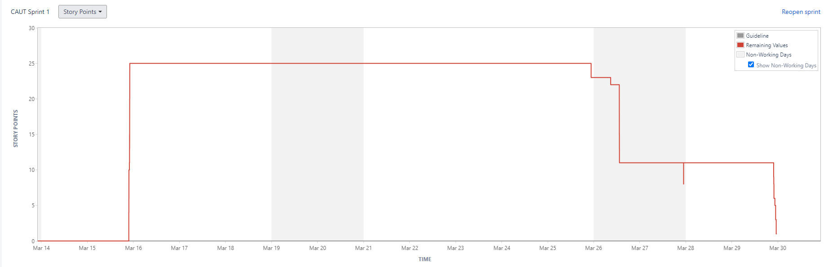

Generated at Tue Mar 29 23:25:51 IST 2022 by Maithreyan S using Jira 7.12.3#712004-sha1:5ef91d760d7124da5ebec5c16a948a4a807698df.

**4.2) Sprint 2 Standup Notes**

**STANDUP NOTES 1 on 22/02/2022**

**Section**: **C** **Project Title**: **Automated elective Processing**

|  |  |  |  |
| --- | --- | --- | --- |
| **Name** | **Question** | **Answer** | **Sign** |
| Santhosh Bharathi | What did you do yesterday? | - |  |
| What will you do today? | Prepare the abstract for automated elective processing, discuss about the requirements. |  |
| Are there any impediments in your way? | None |  |
| Maithreyan | What did you do yesterday? | - |  |
| What will you do today? | Prepare the abstract for automated elective processing, identify the stakeholders for the project. |  |
| Are there any impediments in your way? | None |  |
| Saurav | What did you do yesterday? | - |  |
| What will you do today? | Come up with the required modules and identify the stakeholders for the projects. |  |
| Are there any impediments in your way? | None |  |
| Tejaswi | What did you do yesterday? | - |  |
| What will you do today? | Come up with the required modules and propose a basic framework for our project. |  |
| Are there any impediments in your way? | None |  |
| Viswabharathi | What did you do yesterday? | - |  |
| What will you do today? | Prepare the abstract, and propose a basic framework for the project. |  |
| Are there any impediments in your way? | None |  |

Faculty Name and Signature:

**STANDUP NOTES 2 on 24/02/2022**

**Section**: **C** **Project Title**: **Automated elective Processing**

|  |  |  |  |
| --- | --- | --- | --- |
| **Name** | **Question** | **Answer** | **Sign** |
| Santhosh Bharathi | What did you do yesterday? | Identified the requirements, normal requirements and excited requirements. Assisted with the abstract. |  |
| What will you do today? | Come up with user stories for the epic ‘Teacher’s access’ and identify the tasks for the user stories under this epic. |  |
| Are there any impediments in your way? | None |  |
| Maithreyan | What did you do yesterday? | Identified the stakeholders and assisted in the completion of the abstract. |  |
| What will you do today? | Come up with user stories for the epic ‘Elective Allocation’ and identify the tasks for the user stories under this epic. |  |
| Are there any impediments in your way? | No |  |
| Saurav | What did you do yesterday? | Decided the modules and identified the stakeholders. |  |
| What will you do today? | Come up with user stories for the epic ‘Elective change’ and identify the tasks for the user stories under this epic. |  |
| Are there any impediments in your way? | None |  |
| Tejaswi | What did you do yesterday? | Proposed a basic framework for the progress of our project. |  |
| What will you do today? | Come up with user stories for the epic ‘Dashboard’ and identify the tasks for the user stories under this epic. |  |
| Are there any impediments in your way? | None |  |
| Viswabharathi | What did you do yesterday? | Assisted with the framework planning and helped in completing the abstract. |  |
| What will you do today? | Come up with user stories for the epic ‘Elective Selection’ and identify the tasks for the user stories under this epic. |  |
| Are there any impediments in your way? | None |  |

Faculty Name and Signature:

**STANDUP NOTES 3 on 26/02/2022**

**Section**: **C** **Project Title**: **Automated elective Processing**

|  |  |  |  |
| --- | --- | --- | --- |
| **Name** | **Question** | **Answer** | **Sign** |
| Santhosh Bharathi | What did you do yesterday? | Framed the user stories for the epic ‘Teacher’s access’ and identified the underlying tasks. |  |
| What will you do today? | Develop a schema(tables) with required entities and attributes |  |
| Are there any impediments in your way? | None |  |
| Maithreyan | What did you do yesterday? | Framed the user stories for the epic ‘Elective allocation’ and identified the underlying tasks. |  |
| What will you do today? | Identify the master table and transaction tables in the schema, set primary keys and foreign keys. |  |
| Are there any impediments in your way? | None |  |
| Saurav | What did you do yesterday? | Framed the user stories for the epic ‘Elective change’ and identified the underlying tasks. |  |
| What will you do today? | Identify the functional dependencies in the schema and start normalization. |  |
| Are there any impediments in your way? | Faced difficulties in framing the functional dependencies, sorted the problem. |  |
| Tejaswi | What did you do yesterday? | Framed the user stories for the epic ‘Dashboard’ and identified the underlying tasks. |  |
| What will you do today? | Normalize the tables till 2NF. |  |
| Are there any impediments in your way? | Faced issues with normalization, completed with assistance. |  |
| Viswabharathi | What did you do yesterday? | Framed the user stories for the epic ‘Elective selection’ and identified the underlying tasks. |  |
| What will you do today? | Normalize the tables till 3NF. |  |
| Are there any impediments in your way? | Tried BCNF but our tables are consistent with 3NF itself. |  |

Faculty Name and Signature:

**STANDUP NOTES 4 on 2/03/2022**

**Section**: **C** **Project Title**: **Automated elective Processing**

|  |  |  |  |
| --- | --- | --- | --- |
| **Name** | **Question** | **Answer** | **Sign** |
| Santhosh Bharathi | What did you do yesterday? | Developed the basic schema and relational database. |  |
| What will you do today? | Complete the activity diagram. |  |
| Are there any impediments in your way? | None |  |
| Maithreyan | What did you do yesterday? | Identified the master table, transaction table and formulated the primary keys and foreign keys |  |
| What will you do today? | Complete the state diagram |  |
| Are there any impediments in your way? | None |  |
| Saurav | What did you do yesterday? | Formulated the functional dependencies and started normalization. |  |
| What will you do today? | Complete the sequence diagram. |  |
| Are there any impediments in your way? | None |  |
| Tejaswi | What did you do yesterday? | Normalized the tables till 2NF. |  |
| What will you do today? | Complete the use case diagram and level 1 dataflow diagram. |  |
| Are there any impediments in your way? | None |  |
| Viswabharathi | What did you do yesterday? | Normalized the tables till 3NF from 2NF. |  |
| What will you do today? | Complete the class diagram and level 2 dataflow diagram. |  |
| Are there any impediments in your way? | None |  |

Faculty Name and Signature:

**STANDUP NOTES 5 on 4/03/2022**

**Section**: **C** **Project Title**: **Automated elective Processing**

|  |  |  |  |
| --- | --- | --- | --- |
| **Name** | **Question** | **Answer** | **Sign** |
| Santhosh Bharathi | What did you do yesterday? | Completed the activity diagram. |  |
| What will you do today? | Start coding the login page, create username and password text fields. |  |
| Are there any impediments in your way? | Got errors in instantiating flutter, solved after updating the version. |  |
| Maithreyan | What did you do yesterday? | Completed the state diagram. |  |
| What will you do today? | Create database, add master and transaction tables by instantiating docker. |  |
| Are there any impediments in your way? | Faced issues with docker instantiation. |  |
| Saurav | What did you do yesterday? | Completed the sequence diagram. |  |
| What will you do today? | Pull Mongo image from docker and connect it with the backend. |  |
| Are there any impediments in your way? | Image was bulky to download. |  |
| Tejaswi | What did you do yesterday? | Completed the use case diagram and level 1 DFD diagram. |  |
| What will you do today? | Start coding the elective agreement policy page, create texts and buttons. |  |
| Are there any impediments in your way? | None |  |
| Viswabharathi | What did you do yesterday? | Completed the class diagram and level 2 DFD diagram. |  |
| What will you do today? | Start coding the students’ dashboard page, create calendar widget. |  |
| Are there any impediments in your way? | Calendar widget was hard to implement |  |

Faculty Name and Signature:

**STANDUP NOTES 6 on 6/03/2022**

**Section**: **C** **Project Title**: **Automated elective Processing**

|  |  |  |  |
| --- | --- | --- | --- |
| **Name** | **Question** | **Answer** | **Sign** |
| Santhosh Bharathi | What did you do yesterday? | Created username and password text fields in login page. |  |
| What will you do today? | Create login button and use regex for validation. |  |
| Are there any impediments in your way? | None. |  |
| Maithreyan | What did you do yesterday? | Created master table and transaction tables in the database. |  |
| What will you do today? | Test the connection with the backend by sending a sample json file. |  |
| Are there any impediments in your way? | None. |  |
| Saurav | What did you do yesterday? | Pulled the mango DB docker image and connected with the backend. |  |
| What will you do today? | Configure the docker image of mango DB with the local host |  |
| Are there any impediments in your way? | Faced issues with configuration. Solved with some assistance. |  |
| Tejaswi | What did you do yesterday? | Listed out the agreements and created a checked box button in election agreement policy page. |  |
| What will you do today? | Finish the election agreement policy page by adding colors and icons. |  |
| Are there any impediments in your way? | None |  |
| Viswabharathi | What did you do yesterday? | Created Calendar widget in the student’s dashboard page and created a dart file for the color theme of our project. |  |
| What will you do today? | Create a notification card widget and elective list widget. |  |
| Are there any impediments in your way? | None. |  |

Faculty Name and Signature:

**STANDUP NOTES 7 on 9/03/2022**

**Section**: **C** **Project Title**: **Automated elective Processing**

|  |  |  |  |
| --- | --- | --- | --- |
| **Name** | **Question** | **Answer** | **Sign** |
| Santhosh Bharathi | What did you do yesterday? | Created login button and finished the front-end validation. |  |
| What will you do today? | Start coding the faculty dashboard page, create a side bar menu with list tile. |  |
| Are there any impediments in your way? | Image size was big, got issues with rendering. |  |
| Maithreyan | What did you do yesterday? | Tested the connection with the backend by sending a sample json file. |  |
| What will you do today? | Create API calls for retrieving elective courses from database. |  |
| Are there any impediments in your way? | POSTMAN installation took a long time. |  |
| Saurav | What did you do yesterday? | Configured the docker image of mango DB with the local host. |  |
| What will you do today? | Connect the mango DB with Node Express. |  |
| Are there any impediments in your way? | None. |  |
| Tejaswi | What did you do yesterday? | Completed the elective agreement policy page. |  |
| What will you do today? | Start coding the elective selection form page, set background color and apply color theme to the web page. |  |
| Are there any impediments in your way? | None |  |
| Viswabharathi | What did you do yesterday? | Created notification card widget and elective list widget in the student’s dashboard page. |  |
| What will you do today? | Create a sidebar menu with list tile that have options to navigate to other web pages. |  |
| Are there any impediments in your way? | None. |  |

Faculty Name and Signature:

**STANDUP NOTES 8 on 12/03/2022**

**Section**: **C** **Project Title**: **Automated elective Processing**

|  |  |  |  |
| --- | --- | --- | --- |
| **Name** | **Question** | **Answer** | **Sign** |
| Santhosh Bharathi | What did you do yesterday? | Created Sidebar Menu in faculty dashboard page. |  |
| What will you do today? | Create a logout button and redirect it to logout page. |  |
| Are there any impediments in your way? | Got error that global key value can’t be null, solved after rectifying the bug. |  |
| Maithreyan | What did you do yesterday? | Created API calls for retrieving elective courses from the database. |  |
| What will you do today? | Populate the database by adding student and faculty users. |  |
| Are there any impediments in your way? | None |  |
| Saurav | What did you do yesterday? | Connected the database with the backend. |  |
| What will you do today? | Create API calls user registration and user login. |  |
| Are there any impediments in your way? | Got an error with the management of json files. |  |
| Tejaswi | What did you do yesterday? | Added the color theme to elective selection web page. |  |
| What will you do today? | List down the electives in the web page by accessing the json file. |  |
| Are there any impediments in your way? | None. |  |
| Viswabharathi | What did you do yesterday? | Created a sidebar menu with list tile that have options to navigate to other web pages |  |
| What will you do today? | Display the available elective in the dashboard page. |  |
| Are there any impediments in your way? | None. |  |

Faculty Name and Signature:

**STANDUP NOTES 9 on 15/03/2022**

**Section**: **C** **Project Title**: **Automated elective Processing**

|  |  |  |  |
| --- | --- | --- | --- |
| **Name** | **Question** | **Answer** | **Sign** |
| Santhosh Bharathi | What did you do yesterday? | Created logout button and redirected it to logout page. |  |
| What will you do today? | Create a table to update course workflow in the faculty dashboard page. |  |
| Are there any impediments in your way? | None. |  |
| Maithreyan | What did you do yesterday? | Populated the database by adding student and faculty users. |  |
| What will you do today? | Ensure that json files are sent and received while accessing database. |  |
| Are there any impediments in your way? | None |  |
| Saurav | What did you do yesterday? | Created API calls user registration and user login. |  |
| What will you do today? | Create API calls for elective addition and elective selection. |  |
| Are there any impediments in your way? | None |  |
| Tejaswi | What did you do yesterday? | Listed the electives in the web page by accessing the json file. |  |
| What will you do today? | Create a field to number the elective preference. |  |
| Are there any impediments in your way? | None |  |
| Viswabharathi | What did you do yesterday? | Displayed the available elective in the dashboard page. |  |
| What will you do today? | Start coding the change password page. |  |
| Are there any impediments in your way? | None |  |

Faculty Name and Signature:

**STANDUP NOTES 10 on 17/03/2022**

**Section**: **C** **Project Title**: **Automated elective Processing**

|  |  |  |  |
| --- | --- | --- | --- |
| **Name** | **Question** | **Answer** | **Sign** |
| Santhosh Bharathi | What did you do yesterday? | Created a table to update course workflow in the faculty dashboard page. |  |
| What will you do today? | Connect the teacher’s dashboard page with login page after verifying the validation. |  |
| Are there any impediments in your way? | None |  |
| Maithreyan | What did you do yesterday? | Ensured that json files are sent and received while accessing database. |  |
| What will you do today? | Create an add elective page for admin to enter the elective details |  |
| Are there any impediments in your way? | None |  |
| Saurav | What did you do yesterday? | Created API calls for elective addition and elective selection. |  |
| What will you do today? | Create a button in elective selection page and connect the elective selection page with dashboard page. |  |
| Are there any impediments in your way? | None. |  |
| Tejaswi | What did you do yesterday? | Created a field to number the elective preference. |  |
| What will you do today? | Customize the text style and font color in elective selection webpage. |  |
| Are there any impediments in your way? | None. |  |
| Viswabharathi | What did you do yesterday? | Started with the change password page. |  |
| What will you do today? | Create two text fields in change password page for entering the old password and new password. |  |
| Are there any impediments in your way? | None. |  |

Faculty Name and Signature:

**STANDUP NOTES 11 on 22/03/2022**

**Section**: **C** **Project Title**: **Automated elective Processing**

|  |  |  |  |
| --- | --- | --- | --- |
| **Name** | **Question** | **Answer** | **Sign** |
| Santhosh Bharathi | What did you do yesterday? | Connected the teacher’s dashboard page with login page after verifying the validation. |  |
| What will you do today? | Properly ensure the navigation of webpages in faculty dashboard. |  |
| Are there any impediments in your way? | None |  |
| Maithreyan | What did you do yesterday? | Created an add elective page for admin to enter the elective details |  |
| What will you do today? | Completed the add elective page. |  |
| Are there any impediments in your way? | None |  |
| Saurav | What did you do yesterday? | Completed the elective selection webpage by adding appropriate widgets. |  |
| What will you do today? | Begin with the add user webpage for admin to register users. |  |
| Are there any impediments in your way? | None |  |
| Tejaswi | What did you do yesterday? | Customized the text style and font color in elective selection webpage. |  |
| What will you do today? | Connect the elective selection webpage with dashboard and ensure the proper navigation. |  |
| Are there any impediments in your way? | None |  |
| Viswabharathi | What did you do yesterday? | Created two text fields in change password page for entering the old password and new password. |  |
| What will you do today? | Completed the change password webpage. |  |
| Are there any impediments in your way? | None. |  |

Faculty Name and Signature:

Backlog Grooming

## **Team Name:** **CAUT**

## **Project Title:** **Automated Elective Processing**

## **Team details**

|  |  |  |  |
| --- | --- | --- | --- |
| **Roll Number** | **Name** | **Role for Sprint 1** | **Marks (10)** |
| CB.EN.U4CSE19214 | Santhosh Bharathi E | Web designer/ Tester |  |
| CB.EN.U4CSE19225 | Maithreyan S | Backend Developer/ Database administrator |  |
| CB.EN.U4CSE19243 | Saurav S | Web designer/ Backend Developer |  |
| CB.EN.U4CSE19259 | Tejaswi S | Web designer/ Business Analyst |  |
| CB.EN.U4CSE19263 | Viswabharathi K A | Scrum Master/ Web designer |  |

Faculty name and signature:

# Epic 1 - User Authentication and Validation

## Story 1 - User Registration – As an admin, I would like to register users.

|  |  |  |  |
| --- | --- | --- | --- |
| **Task** | **Member** | **Priority** | **Estimate (Hours)** |
| Design Registration page | Santhosh | High Priority | 1hr |
| Implement the registration page with relevant UI, icons and images | Tejaswi | Medium | 1hr |
| Implement registration form validation | Saurav | High |  |
| Create SQL scripts to create tables | Maithreyan | High | 2hrs |
| Create triggers on user registration | Saurav | High | 1hr |
| Store registered user credentials in the database | Viswabharathi | Medium | 0.5 hrs |

## Story 2 - User login- As a user, I would like to login effortlessly

|  |  |  |  |
| --- | --- | --- | --- |
| **Task** | **Member** | **Priority** | **Estimate (Hours)** |
| Design login page for teachers | Tejaswi | Medium | 2hrs |
| Design login page for students | Santhosh | Medium | 2hrs |
| Design login page for admin | Viswabharathi | Medium | 2hrs |
| User mapping/ authentication (credentials verification) | Maithreyan | High | 1hr |
| Clear credentials functionality | Saurav | low | 0.5hrs |

## Story 3 - User logout- As a user, I would like to logout effortlessly

|  |  |  |  |
| --- | --- | --- | --- |
| **Task** | **Member** | **Priority** | **Estimate (Hours)** |
| Button to logout | Viswabharathi | low | 0.5hrs |
| Confirm before logout | Viswabharathi | low | 0.5hrs |
| Redirect the user to the logout screen | Viswabharathi | medium | 0.5hrs |

# Epic 2 - Dashboard

## Story 1 - Manage passwords: As a user, I want to be able to change/improve my auth services

|  |  |  |  |
| --- | --- | --- | --- |
| **Task** | **Member** | **Priority** | **Estimate (Hours)** |
| Create a change password option | Saurav | High | 1hr |
| Design a Change Password page | Tejaswi | High | 1hr |
| Add a button Change password that is connected to Database | Viswabharathi | High | 1hr |
| Add an alert dialogue box if there was an error in changing password | Maithreyan | medium | 1hr |

## Story 2- Implement change password workflow in DB: As a student, I want to be able to change my password preference

|  |  |  |  |
| --- | --- | --- | --- |
| **Task** | **Member** | **Priority** | **Estimate (Hours)** |
| Validate password | Saurav | high | 1hr |

# Epic 2 – Elective selection

## Story 1 - As a student, I need to choose my elective preferences.

|  |  |  |  |
| --- | --- | --- | --- |
| **Task** | **Member** | **Priority** | **Estimate (Hours)** |
| Design an elective selection webpage | Tejaswi | High | 2hrs |
| Lists every elective on the webpage that are offered by accessing the course database | Tejaswi | medium | 1hrs |
| Add a number field alongside the elective name, for ordering the preference. | Tejaswi | medium | 2hrs |

## Story 2- As a student, I want an elective allocation agreement policy page

|  |  |  |  |
| --- | --- | --- | --- |
| **Task** | **Member** | **Priority** | **Estimate (Hours)** |
| Create a button on the elective selection webpage and link it to the policy webpage | Santhosh | medium | 2hrs |
| Design an agreement policy webpage that states the agreement policy. | Santhosh | medium | 1hr |
| List out all the policies and terms for choosing elective preference in the policy webpage | Viswabharathi | medium | 1hr |
| Create a Button and a text alongside stating “I have read the terms and ready to proceed further”. | Santhosh | high | 10min |

# Epic 4- Teacher’s Access over the portal

## Story 1 - Teacher's homepage

|  |  |  |  |
| --- | --- | --- | --- |
| **Task** | **Member** | **Priority** | **Estimate (Hours)** |
| Dashboard | Santhosh | High | 8hrs |
| Logout | Tejaswi | High | 1hr |

## Story 2 - Update workflow

|  |  |  |  |
| --- | --- | --- | --- |
| **Task** | **Member** | **Priority** | **Estimate (Hours)** |
| Input fields for course details | Santhosh | high | 1hr |
| Input fields update by the teacher | Santhosh | high | 1hr |

**6) Sample Code**

**Frontend:**

**Login page:**

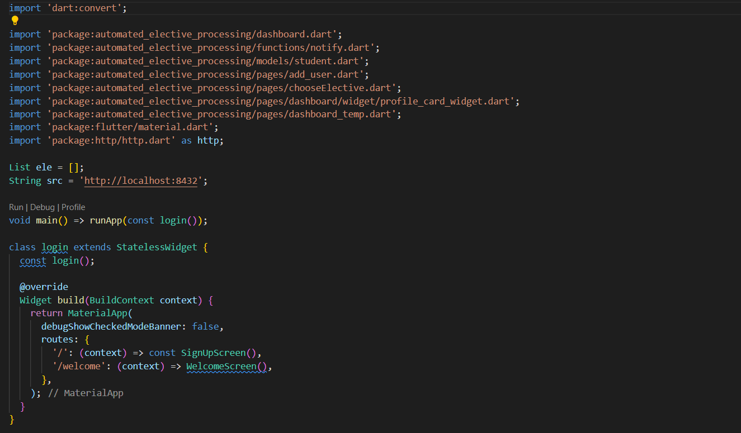

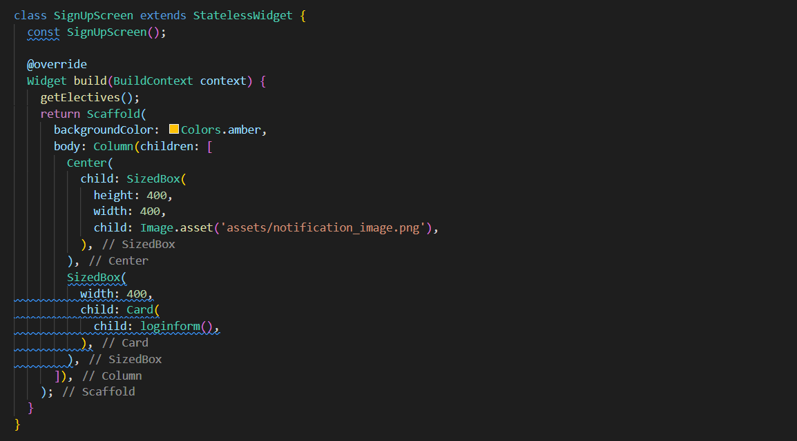

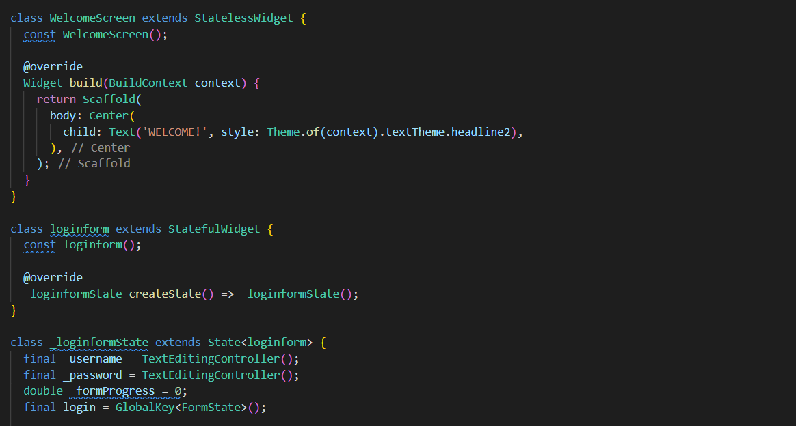

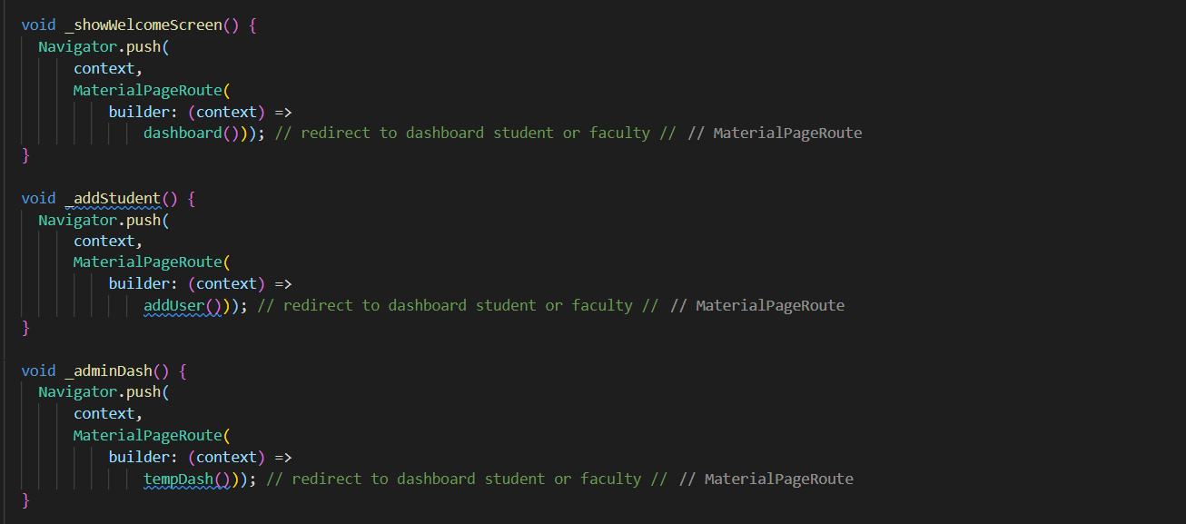

**Student dashboard:**

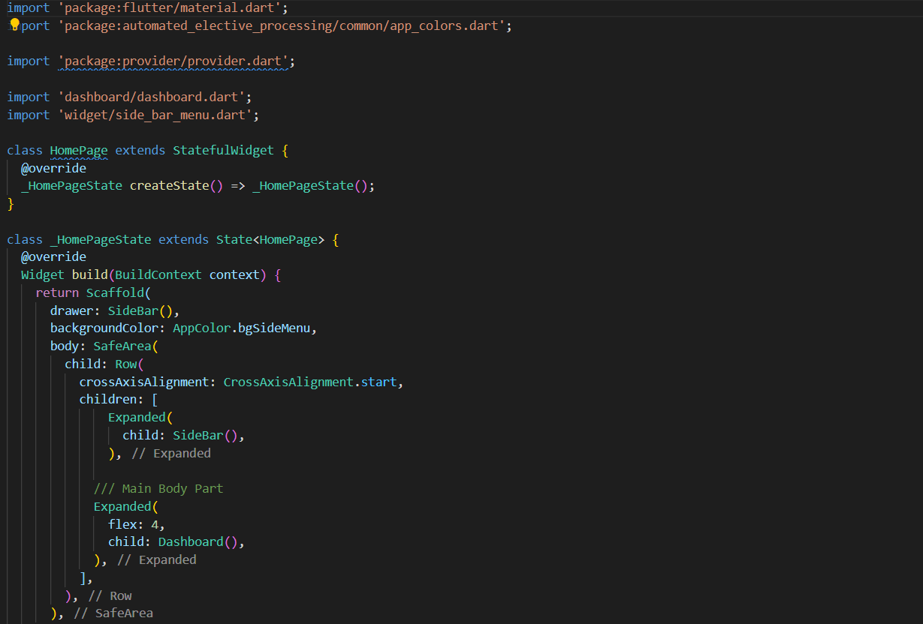

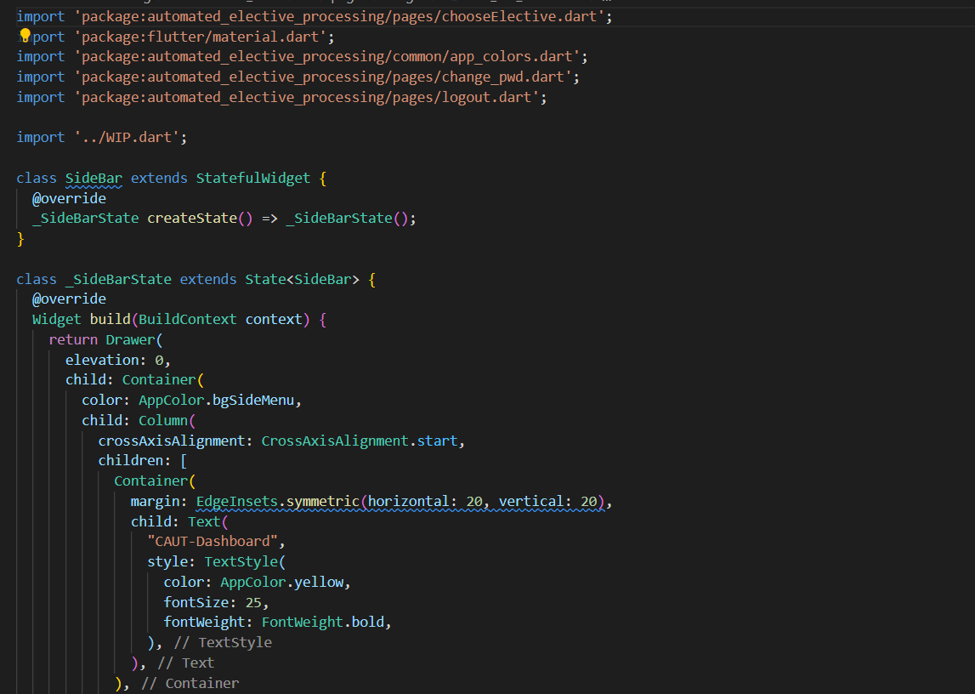

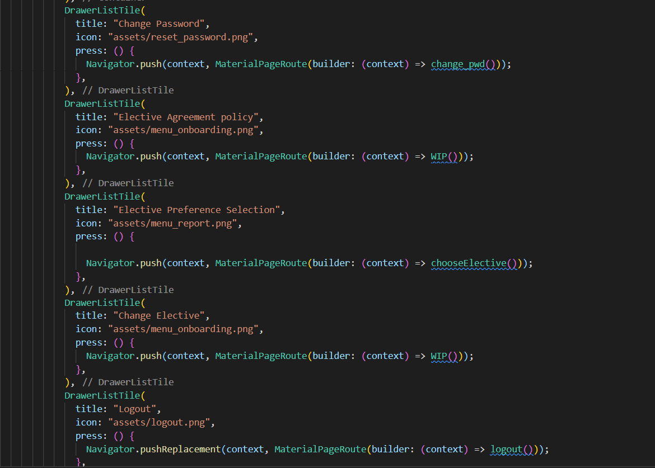

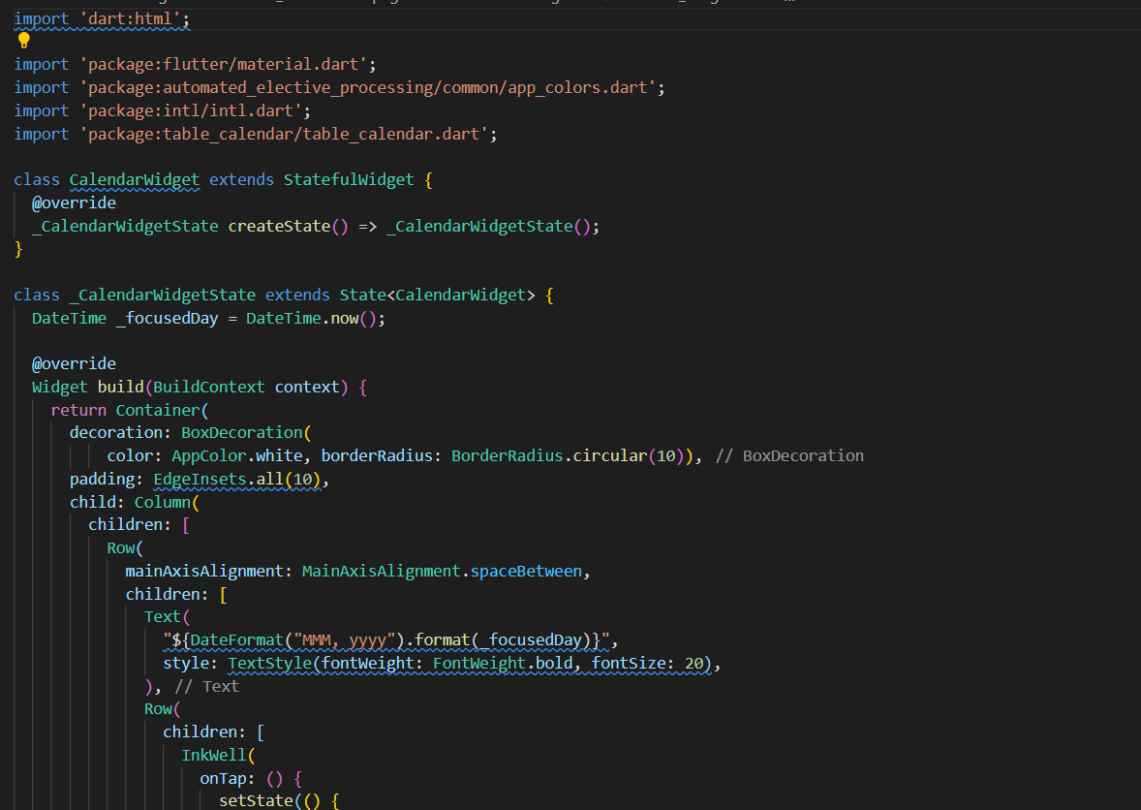

**Database**

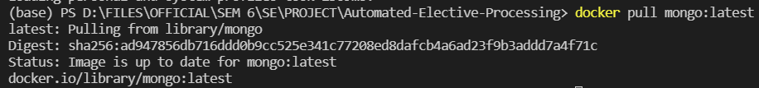

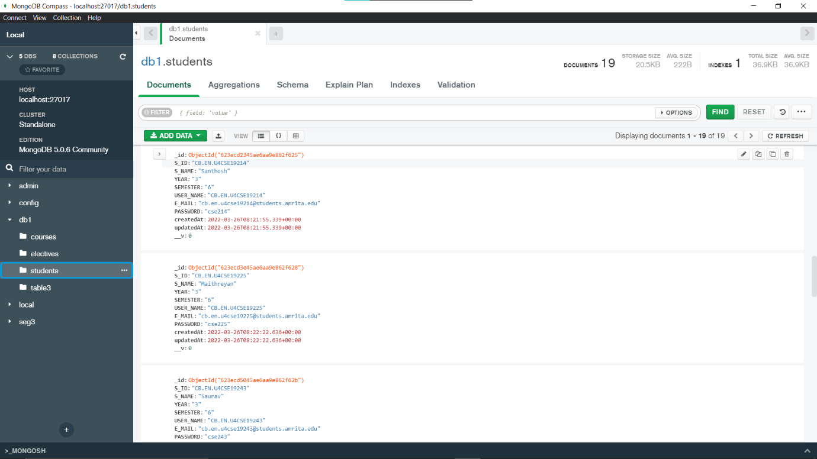

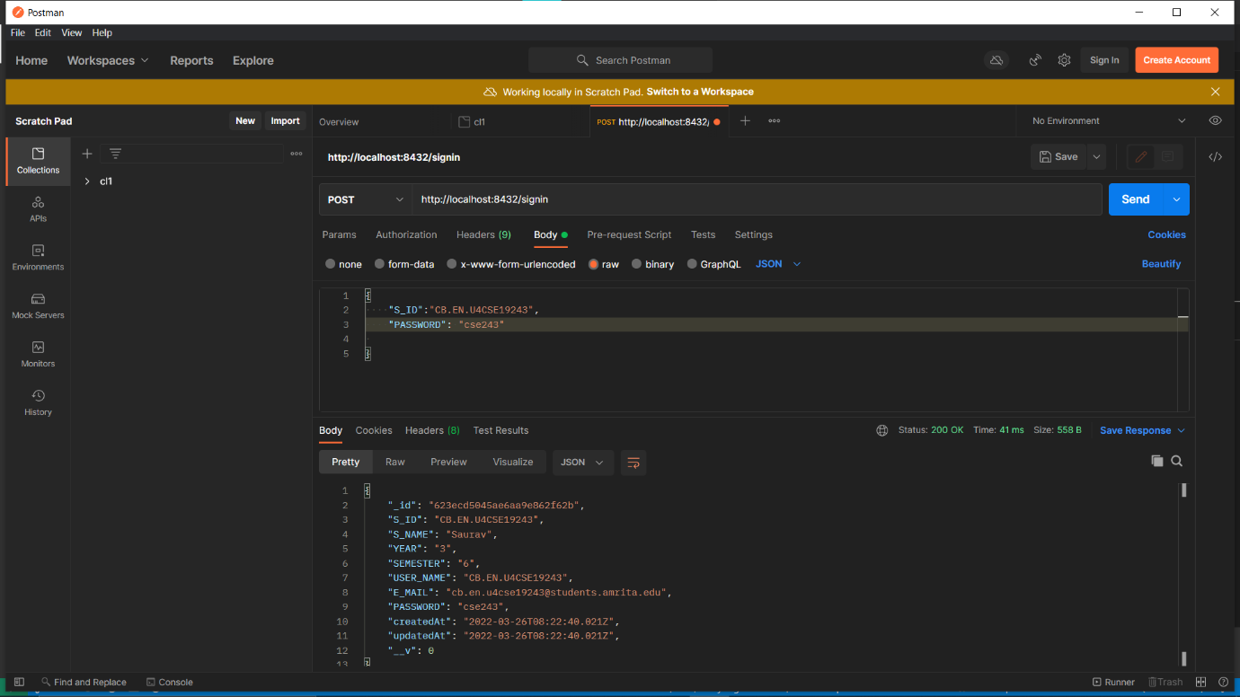

**Backend:**

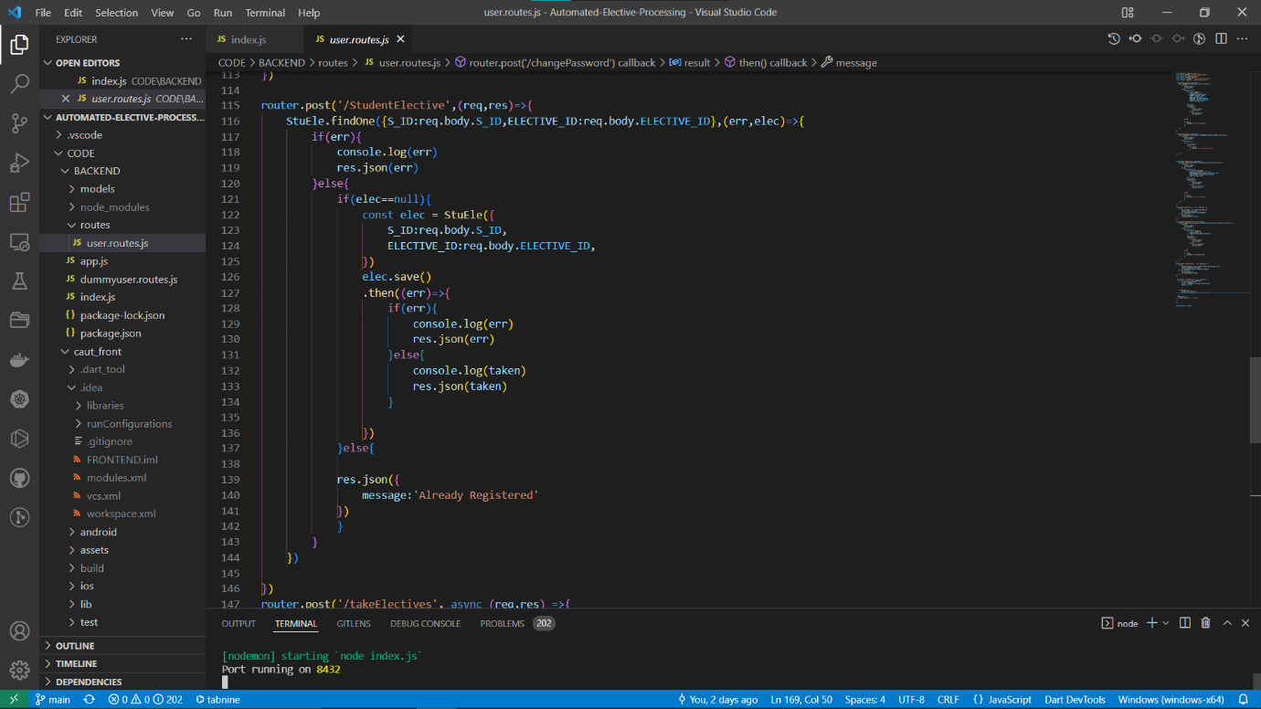

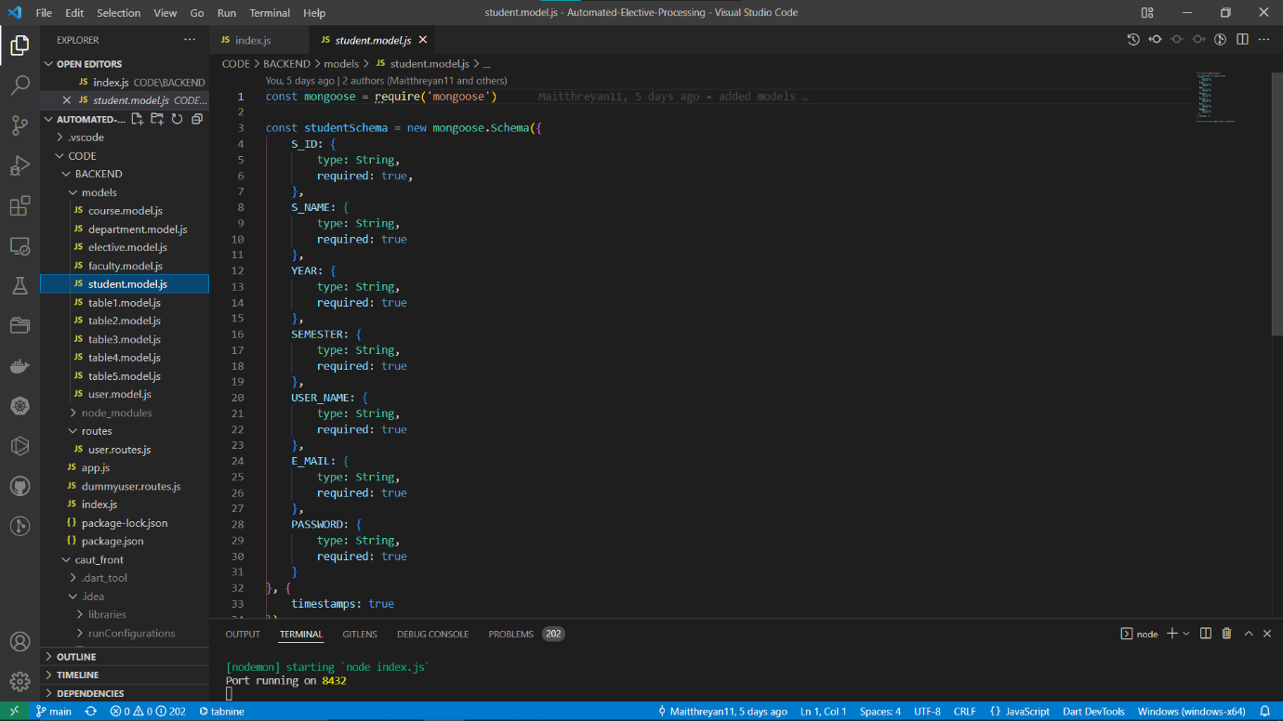

**8) Screenshot of the project**

